Beirut Arab University
Faculty of Science
Department of Computer Science
Senior Project I (CMPS 443)
SAWTAK
صوتك
An AI-Assisted Lebanese Social Platform for Constructive Public Dialogue
Your Voice. Our Dialogue. One Lebanon.
Ali Kefel —202403197
Hadi Muselmani — 202304319
Mostafa Hammoud — 202303081
Hussein Dakik —202402938
Hussein Chehime — 202305148

Supervisor
Dr Mahmoud El Skafi,

Acknowledgements
We would like to express our sincere gratitude to our supervisor, Dr Mahmoud El Skafi, for his guidance, patience, and continuous feedback throughout Senior Project I. His direction determined both the scope of this project and the rigour with which we approached its analysis and design.
We also thank the Department of Computer Science and the Faculty of Science at Beirut Arab University for providing the scholarly environment and the resources that made this work possible.
Finally, we thank the eighty-eight respondents who completed our survey. Their answers turned an assumption about Lebanese online discourse into concrete evidence, and much of the direction of this project follows directly from what they told us.

Abstract

Four issues in online public conversation in Lebanon can be singled out and viewed as interconnected: engagement-based algorithm that favors hostility over logic, intimidation due to real-name identity which is permanent and always-on, algorithmic filter bubbles limiting exposure to the opposite point of view, and quick spreading of unchecked claims because there is no structured verification layer for Lebanese people. An 88-member survey conducted among Lebanese respondents within this project found out that 93% of the participants use social media several times a day, 75% encounter offensive and harmful content at least sometimes, and 36 respondents mentioned toxic comments and hate speech among the top concerns.

In this report we present the analysis and design of Sawtak (صوتك, "Your Voice"), socially conscious Lebanese platform supported by artificial intelligence which seeks to foster productive disagreements instead of trying to eliminate them. Unlike regular browsing of feeds, Sawtak offers an interactive dialogue feature called Agree / Disagree which allows turning all points of view into measurable signals. Moreover, automated content analysis is performed to classify category, topic and opinion from 0 to 5.

Two innovative technologies characterize the platform: Echo Chamber Breaker builds the opinion profile of the user based on his/her activity, assesses the diversity of opinions that the user was exposed to recently and recommends him/her an opinion somewhat diverging from his/her own using a custom recommendation algorithm; also, it reveals the points of common interest. NLP-Based News Verification pipeline performs Named Entity Recognition and Claim Extraction, looks for corroboration in credible external sources, performs semantic, entity and temporal matching and gives an evidence score from 0 to 5 with sources cited. The answer will never be True or False.

In all cases the platform works under the hard requirement: religion, sect, political affiliation and ethnicity cannot be determined and stored in any form by Sawtak. Any behavioral analysis will be private to the user and will never be disclosed publicly as the user's label.

Senior Project I comprises requirements analysis, a six-dimensional feasibility study, project planning and risk management, UI prototypes and system design: use case model, data flow model, entity relationship model, class model, sequence diagram and architecture design. Implementation, integration, evaluation and deployment will occur during Senior Project II.

Table of Contents
Acknowledgements 1
Abstract 2
Table of Contents 3
Chapter 1. Introduction 4
A. Main Project Description 5
B. Statement of the Problem 5
The motivation behind this project is rooted in the following four concerns. Each was identified through analysis of existing systems and confirmed using primary data, collected via a survey from 88 Lebanese participants. 6
Problem 1 – Toxicity and aggression 6
In engagement-based ranking, emotional reaction is more rewarded than meaningful conversation. Outrage spreads faster than well-researched opinion, and the revenue model of a platform that gains money based on how much time people spend using it cannot financially afford to slow it down. According to the results of our survey, 75% of respondents face offensive content at least sometimes, and 36 out of 88 mentioned toxic comments and hate speech as one of the worst problems for them. 6
Problem 2 – fear of expression 6
People refrain from participating in sensitive discussions if their true identity will be always tied to their opinion. In a country where political and sectarian affiliation is an actual factor of life, there emerges a "freezing" effect: performance is replaced by meaningful conversation, and opinions presented are not those that were meant to be expressed. 6
Problem 3 – information bubbles 6
Algorithmic feeds provide users only with what is at least somehow familiar. Thus, their ability to receive new opinions is limited, and the result of that is the polarisation of society. Citizens do not have access to other citizens' opinions, and each party sees the opposition as even more extremist and numerically smaller than they are. 6
Problem 4 – false and verified news 6
Claims appear and then are verified by the independent sources. There is no verification system for the Lebanese audience; therefore, the situation becomes prone to disinformation. At present, there are very few global fact-checking platforms in existence that can cover news events in Lebanon, are available in Arabic, or understand code-switching from Arabic into English which is typical for the Lebanese news and commentaries. 7
The four mentioned problems lead to: absence of mechanisms to measure the mood of national conversation; absence of structured way to voice partial/middle position; absence of recommendation algorithm widening the horizon of users; absence of verification service producing information without defamation. C. Purpose of the project 7
D. Project Stakeholders 8
Chapter 2. Feasibility Study 8
A. Functional Feasibility 9
Market Feasibility 9
Review of existing systems 9
Market evidence 9
Legal Feasibility 10
Social Feasibility 10
Environmental Feasibility 11
B. Economic and Financial Feasibility 11
C. Technical Feasibility 12
Chapter 3. Project Plan 13
A. SDLC Model 14
Management roles within the SDLC 14
B. Work Packages 15
C. Project Schedule 15
D. Team Roles 15
E. Budget and Cost Estimation 15
F. Project Monitoring and Control 16
Risk Management 16
Quality Assurance 16
Chapter 4. Software Requirement Specification 16
A. Product Functions 17
Stretch features 17
B. User Permissions and Types 18
C. Functional Requirements 18
Use case descriptions 19
D. Non-functional Requirements 20
E. Domain Requirements 20
Chapter 5. Project Design 20
A. User Interface Prototype 21
B. Use Case Diagram 26
C. Data Flow Diagram 27
Level 0 — context diagram 27
D. Database Diagram 29
E. Domain/Class/Object Diagrams 31
F. Sequence Diagrams 32
Chapter 6. Implementation Plan 35
B. Testing Plan 37
C. Deployment Plan 38
D. Maintenance Plan 39
Chapter 7. Summary and Future Work 39
Future work 40
Chapter 8. References 41
Appendices 43
A. Position and Verification Scales 44
B. Recommendation Algorithm Weighting 44
C. Worked Example — Claim Extraction and Evidence 44
D. Echo Chamber Score — Worked Example 45
E. Remaining Items Prior to Submission 45

Chapter 1. Introduction

A. Main Project Description

Sawtak (صوتك - Arabic for “Your Voice”) is a social platform driven by AI which is intended for supporting the public discourse in Lebanon. Sawtak connects three areas of research: social computing and design of discussion platforms, natural language processing (NLP) and opinion classification and verification, and recommender systems with a particular focus on filter bubbles and feed design which expands the user's opinion horizon instead of narrowing it.

The key idea of this project is that the issue with disagreement in the online environment is not the disagreement itself but the fact that the mainstream social media platforms are built in such a way as to maximize engagement while hostility engages. Thus, Sawtak does not seek to make people agree but to change the nature of their disagreements.

There are five main principles underpinning the platform:

• Lebanese – a platform dedicated to Lebanese discourse, culture and language (Arabic, English and mixed).

• Structured interactions – an Agree/Disagree mechanism takes place of scrolling, thus structuring the opinion exchange process, not leaving it anonymous.

• AI-driven – content analysis, echo chamber detection and news verification integrated into the experience.

• Privacy-focused – no sensitive data profiling; the AI only analyses content and interactions, never religion, sect or political affiliations.

• Two technological innovations – Echo Chamber Breaker and NLP-based news verification, representing the technological component of the project.

Senior Project I which includes the analysis and design of the platform is presented in this report. This particular approach has been adopted on purpose since full-scale analysis and design create a solid foundation for coding, done in Senior Project II.

B. Statement of the Problem
The motivation behind this project is rooted in the following four concerns. Each was identified through analysis of existing systems and confirmed using primary data, collected via a survey from 88 Lebanese participants.

Problem 1 – Toxicity and aggression

In engagement-based ranking, emotional reaction is more rewarded than meaningful conversation. Outrage spreads faster than well-researched opinion, and the revenue model of a platform that gains money based on how much time people spend using it cannot financially afford to slow it down. According to the results of our survey, 75% of respondents face offensive content at least sometimes, and 36 out of 88 mentioned toxic comments and hate speech as one of the worst problems for them.

Problem 2 – fear of expression

People refrain from participating in sensitive discussions if their true identity will be always tied to their opinion. In a country where political and sectarian affiliation is an actual factor of life, there emerges a "freezing" effect: performance is replaced by meaningful conversation, and opinions presented are not those that were meant to be expressed.

Problem 3 – information bubbles

Algorithmic feeds provide users only with what is at least somehow familiar. Thus, their ability to receive new opinions is limited, and the result of that is the polarisation of society. Citizens do not have access to other citizens' opinions, and each party sees the opposition as even more extremist and numerically smaller than they are.

Problem 4 – false and verified news

Claims appear and then are verified by the independent sources. There is no verification system for the Lebanese audience; therefore, the situation becomes prone to disinformation. At present, there are very few global fact-checking platforms in existence that can cover news events in Lebanon, are available in Arabic, or understand code-switching from Arabic into English which is typical for the Lebanese news and commentaries.

The four mentioned problems lead to: absence of mechanisms to measure the mood of national conversation; absence of structured way to voice partial/middle position; absence of recommendation algorithm widening the horizon of users; absence of verification service producing information without defamation. C. Purpose of the project

Sawtak seeks to establish a Lebanese digital space where disagreement serves as an opportunity for discussion rather than division – a space where one can freely express their point of view, receive various views and verify the information that one reads.

The project has the following six objectives:

Objective Description: LINK UP “To create a digital Lebanese space where people will engage in dialogue despite their ideological differences.” “Promote disagreement as a mode of social interaction and make it normal and valuable.” EXAMINE Analysis of the dialogues, responses of the audience, tendencies of opinions and the quality of the content using AI. DIVERSIFY Diversity of opinions moderation in order to avoid the echo-chamber effect. Tell Supply NLP-based verification of news about Lebanon and its content analysis. SUPPORT Reporting, moderation, privacy & appropriate usage of AI on the whole platform.

Table 1.1 – Objectives of the project

The scope of Senior Project I consists of analysis and design needed for achieving these objectives. The scope of Senior I and II work packages is defined in 3. B section.

D. Project Stakeholders
This project seems to pull in a lot of different people who care about how it works out. The main ones are Lebanese users on social media who fall between eighteen and forty. They already deal with the issues the platform wants to solve and they end up giving the opinions that matter most.

It feels like they get something from the part where things get checked and different views show up. Some of them still hold back though. They have thoughts on big national topics but stay quiet because of what could happen if their name stays attached to it forever. That part stands out as pretty important.

Moderators and the people running the platform handle reports and decide on appeals. Their needs probably shape some of the requirements that come up later. The academic side has the supervisor and Beirut Arab University since this is the senior project. They look at whether the analysis holds up and if the next steps seem doable.

Lebanese society in general might gain from the anonymous data that shows what people actually think. External providers like OpenAI and Supabase plus news sources are involved too but I am not totally sure how central they end up being. Some parts of the project might shift depending on how those fit in.
Dependencies rather than beneficiaries. Their availability, pricing, and conditions of use constrain the platform, which is why the AI provider sits behind a substitutable interface. The development team: five students responsible for delivering the design in Senior I and the implementation in Senior II. Table 1.2 — Project stakeholders
The target audience the product is expected to serve is Lebanese users who are already active on social media, who follow public affairs, and who are comfortable reading and writing in Arabic, English, or a mixture of the two. The survey confirms that this audience exists and is engaged: 93% of respondents use social media multiple times per day, and approximately 80% answered Yes or Maybe when asked whether they would use a platform that encouraged constructive and courteous interaction.

Chapter 2. Feasibility Study
In our project we studied 6 different feasibility studies we spoke about each one below.

A. Functional Feasibility

Market Feasibility
Question: Is there a real audience and an unmet need in the Lebanese market?

Review of existing systems
Three classes of systems seem applicable here. Large Lebanese groups already exist on general social networks like twitter and facebook, but they just rank items by popularity and give no actual way to register an opinion or check a claim. Reddit does have threaded conversations and some moderating but its lebanese community is limited and has no arabic support and nothing to measure opinions. Kialo is a structured debate and has some of the same moves as sawtak but it functions more like an argument map than a social network and it does not focus on lebanon or offer arabic.
Sawtak is different because it is lebanese focused and has agree or disagree options plus public opinion views and some ai checks for content and echo chambers. It also has voice rooms and a focus on keeping the conversation constructive. The difference is fairly direct from the user’s perspective. On other sites you scroll and react and wind up seeing more of what you already think, with little sense of whether assertions hold up or how average your feed actually is. On sawtak it is the same individual who has to take a viewpoint before responding and then gets to see live percentage points on the problem.
They are also given a little different perspective at times, as well as the common ground and they can evaluate news assertions for an evidence score. I am not 100% clear how all the ai components work together in practice but that is easy to overlook when just comparing the features.

Market evidence
• High baseline involvement – Lebanon is a high social-media penetration country and 93% of our 88 respondents utilize social media numerous times a day. Sawtak is using an existing behavior; the platform doesn't need to develop a new habit.
Why No direct local rival – there is no existing platform that combines Lebanese focus, structured Agree / Disagree, echo-chamber mitigation and NLP news verification in one solution.
• Well-defined segment — Lebanese users who follow and debate public affairs on the internet, mainly aged 18–40, who are already dealing with the challenges Sawtak is trying to solve.
• Willingness to embrace demonstrated – about 80% of respondents said Yes or Maybe when asked whether they would utilize a platform that promotes positive and respectful contact; 20% said No.

Verdict: Feasible.

Legal Feasibility
Question: Can the platform be operated lawfully and responsibly?
Sawtak is a processor of personal data and a host of content generated by users, which comes with legal obligations. The major legislation in Lebanon is Law No. 81 of 2018 on Electronic Transactions and Personal Data . This law regulates the collecting, processing and keeping of personal data and defines the rights of the data subjects. We looked at four areas of duty.
• Handling of personal data – explicit agreement at sign-up, data minimization – only data necessary by a feature is collected, user access to own data and opportunity to deactivate an account and its related material.
• Responsibilities for user created content – a platform that hosts public opinion content requires a reporting mechanism, a moderation process and an appeal process that can be examined by people. All three are FR-9 and NFR-2.
• No sensitive profiling – the system shall not deduce religion, sect, political affiliation or ethnic group nor keep such information. This is a rigorous design constraint, not a policy choice, just because this data has the biggest danger of harm in the Lebanese context.
• Defamation-free verification — News verification gives a 0-5 evidence score with sources cited, instead of an absolute True/False conclusion. A verdict is the platform’s view on a third party. A score with proof is a claim the reader can verify for themselves. And that difference has to do with design as much as with legal standing.
Verdict: Feasible.
As long as the privacy, consent, moderation and AI-transparency principles are enforced exactly as specified, the platform is legally and ethically feasible. Residual risk: legal assessment of terms of service and data-retention policy is necessary and scheduled prior to public deployment in Senior Project II.

Social Feasibility
Question: Will the platform have a positive effect on Lebanese public discourse?
Sawtak operates in a country where political and sectarian identification is a delicate issue, and where a badly built system could plausibly inflame the divisions it aims to redress. The design is consequently made apparent in its social concepts and each has a corresponding mechanism in the product.
• Promotes courteous contact – organized Agree / Disagree substitutes reaction-driven interaction, so the interface itself incentivizes taking a position rather than escalating a fight.
• It boosts diversity of points of view – The Echo Chamber Breaker puts forward slightly different viewpoints and seeks common ground, rather than emphasizing differences. To present the strongest opposing opinion is to be ignored rather than engaged; to present a moderate difference is to be read.
• Respects a delicate context – Lebanese conversation is politically and sectarian volatile, therefore Sawtak never profiles users by sect, party, ethnicity or religion anywhere in system.
• Presents analysis as self-awareness – AI behavioral analysis is private to the user, and never shown as a public label, which prevents converting analysis into societal judgment. The interface states “Explore another perspective”, never “You are inside an echo chamber” and never “You are biased”.
Verdict: Feasible.

Environmental Feasibility
Question: What is the environmental cost of running Sawtak?
The software platform functions without any physical space but its environmental impact is due to the power that is required to run the computer operations. Computational speed is essential to the platform’s function and cannot be treated as an optimization that can be performed in later stages of the software.

Supabase is hosted in the cloud through a managed service thus eliminating the need for physical servers. The infrastructure of the cloud that is shared by all users is significantly more efficient than self-hosting the software at this size.

The energy cost of the software comes primarily from the AI calls made by the system. The system makes these calls once to classify each post as it is created and then stores the results of these classifications. This eliminates the need for the software to analyze each post each time it is displayed in the feed. The more posts that are created by users creates more energy costs for the platform than the number of users who view the posts.

The system only performs verification of news claims when a user requests it. The system does not perform these verifications on the entire news feed, thus reducing the processing power that is required.

The system is designed with efficiency in mind. Features such as caching, batching, and rate limits are required for the system to function and are not optimizations that can be introduced later into the software platform.
Verdict: Feasible.

B. Economic and Financial Feasibility
Cost drivers and controls

The main cost driver for this project is the AI API calls. For each post, the content is classified once. Additionally, the classification results are cached to avoid calling the API again for the same content. The posts are also processed in batches. These cost controls are the same as those used to keep the cost of the environmental impact low.

Development costs are incurred through the time of the student development team. No salaries are paid for these developers. The technology stack that is used in the project is open source and does not carry any licensing fees.

There are no costs for machines, travel, or training for the student developers. All training and knowledge needed to develop the project is available in publicly available documentation. Additionally, the developers use their own hardware to develop the project.

Will it make economic sense, and will it generate profits?

Since Sawtak is an academic project, there will be no revenue during Senior Project I or II. However, there are several ways in which the project could become sustainable outside of the academic environment. These include licensing the data to other academic institutions or research organizations, receiving grants or sponsorships from organizations interested in the data, or developing premium features for organizations that would like to run their own discussions using Sawtak. Advertising revenue has been explicitly excluded from the design of the project. This is because advertising revenue is associated with maximising engagement from users, which is an incentive that the project was explicitly created to avoid.
Verdict: Feasible.

C. Technical Feasibility
Question: Can the system be built with technologies the team can realistically use?
• Mature, documented stack — The project uses React with TypeScript, Node.js, PostgreSQL with Supabase, and the OpenAI API. Each of these technologies is well established, well supported by the community of developers, and well documented.

• No unproven research required — The innovations in the project are developments built on top of preexisting capabilities of the AI models, specifically in their ability to classify language models and to retrieve information from those models. None of these features require the development of new research or technology, which allows for the completion of the project within two semesters.

• Team capability — The team working on the project is already familiar with the technologies used in the project, including web development, REST APIs, and relational databases. The only remaining area that they will need to learn is the interface with the AI technology to orchestrate its functions within the project.

• Main technical challenge identified — The main technical challenge within the project relates to the ability of the AI models to understand Lebanese Arabic and the code-switching between Arabic and English within the same spoken utterance. The team plans to overcome this challenge through the use of prompt design for the AI models, a neutral response from the models in the event that classification of the languages within an utterance is uncertain, and through the evaluation of the models using utterances of mixed languages during the second semester of the Senior Project.

A further point supporting the technical feasibility of the project is the fact that the AI models are accessed through an interface owned by Sawtak. Therefore, any changes to the models or the providers of those models will not require any changes to the platform itself. Thus, the technology that is the riskiest in terms of external influences is also the easiest to replace within the project.
Verdict: Feasible.

Chapter 3. Project Plan

A. SDLC Model
Sawtak follows an incremental and iterative software development lifecycle. The model was chosen due to the structure of the Sawtak project.

Reason Explanation for Choice of Model

Modular Structure: Sawtak consists of several modules that operate independently of one another. These modules include posts, rooms, messaging, news verification, and AI services. Each of these modules can be created without concern for the others. AI Iteration: Furthermore, the AI functionality within Sawtak requires experimentation with multiple iterations to produce the desired results. Various features, such as classification prompts and scoring weights, cannot be defined prior to implementation. Iterative development allows for these features to be modified over time. Two-Stage Structure: The two stages of development, Senior I and Senior II, complement the incremental development process. Senior I is involved in developing the analysis and design of the platform, while Senior II uses this information to implement the platform’s features. Replaceable AI: The AI features within Sawtak are callable through interfaces that Sawtak owns. Therefore, changing the AI providers or models will not require a redesign of the platform. This modularity of the increments allows for the AI to be replaced without impacting other features. Table 3.1 — Justification of the incremental/iterative SDLC model

A waterfall model was considered but ultimately rejected. This model would suggest that requirements for the platform and its features could be established before the implementation of the software. Such a model does not consider the need for iterative development of the AI features. A fully agile model with sprints was also considered. However, this would not work well with the two-semester academic structure within which this project is being developed.

Management roles within the SDLC
Since the team does not have an outside customer, the supervisor steps in as product owner, establishing acceptance criteria and reviewing completed increments. Following are the suggested team roles for Senior Project II. They purposefully switch roles so that no one member has expert knowledge of every component.

Position within SDLC management Responsible for overseeing the backlog/schedule, establishing milestones, and leading weekly reviews for the role. Coordinator of Projects. Evaluating increments, defining acceptance criteria, and arbitrating judgments regarding scope. Lead Developer (Oversight). Verification of architecture coherence and code merges into the main program repository. Head of Technology. Responsibility for testing plans, administration of test suites, and validation of incremental changes against specifications. Management responsibilities in the software development life cycle (SDLC) and their corresponding table

B. Work Packages
Below you can see the prioritized work breakdown. Both the first and second packages of the senior project are either finished or in the planning stages.
Below you can see the prioritized work breakdown. Both the first and second packages of the senior project are either finished or in the planning stages.

C. Project Schedule

D. Team Roles
We are a group consisting of 5 members and each one of us has contributed somehow equally in making this project complete . Hadi Muselmani complete ERD diagram and introduction of the project and the software requirements and the feasability study , Ali kefel completed the NLP algorithm and designed the uml class diagram , hussein chehime completed the Echo chamber algorithm and worked mon the prototype of sawtak, Mostafa Hamoud worked on the usecase diagram and the SDLC models , hussein dakik Completed the DFD models (0 and 1) and calculated the product estimation of our project .

E. Budget and Cost Estimation
The parameters relevant to the total cost of this project are set out below, following the standard cost model for a software development project.

Cost parameter applies to Sawtak? Detail: Machines and hardware: No additional cost. The team will use their own machines for development. No servers will be purchased, as the hosting is cloud-based. Software and licensing: No cost. React, Node.js, TypeScript, PostgreSQL, and Supabase are all open source or offer free tiers. No commercial licenses are required for these software packages. Cloud and hosting: $0 – $25 / month. Hosting the frontend and the database are both within the free or student tiers given the size of the prototype. Additionally, the OpenAI API cost ranges from $0 to $25 per month. The use of batch jobs, cached results, and the limitation of one classification per post keeps the cost low. This is the only cost that will rise with usage of the prototype. Travel and training: No cost. There is no travel required for this project as the team is remote. Training will be done through self-study using the documentation that is publicly available for the technologies used in the project. Effort and salaries: Not costed. The time of the students is developmental and is noted here for completeness rather than charged to the project. Should the same effort be required from commercial developers, the cost would be substantial. Contingency: Should the free tiers be surpassed during the evaluation of the prototype, there should be a small cost allowance to cover the extra costs that might be incurred. Cost parameters in Table 3.7

Therefore, the total estimated cost per month to operate the prototype of Senior Project II is between $0 and $50 per month. The higher end of the range reflects the usage of the AI through heavy testing of the prototype. All of these values are estimates, and the final costs will be calculated according to the actual use of the components of the project.

F. Project Monitoring and Control

Risk Management
Risks were assessed across four dimensions: AI behaviour, content and abuse, schedule and platform dependency. Each risk has been given a corresponding mitigation that is reflected in the project design.

The mitigation strategies for the AI classification errors include training the AI model on labelled data sets of the target content, using a cut-off value to determine the classification, and setting the decision making process to be neutral for posts with unknown positions on the subject. To account for the use of Lebanese and code-switched Arabic, the data was tested in all of these languages during the project implementation, and adjusted based on the results of these tests. Errors in news verification were mitigated by requiring multiple evidences for all claims, including citations of the sources that the users can see, temporal awareness of the news articles, and a 0-5 rating scale instead of a binary decision. To account for AI hallucinations, the model would explain the evidence that it has retrieved, but it would make no decisions about the score of the news article. The scoring of the news articles was done using a scoring function that was owned by sawtak. For the verification of AI-generated content, issues of false positives on sign-up were addressed.

The back-end system makes a decision on whether to allow, challenge or block a post. Users have the ability to appeal this decision, and a human will review these appeals. Other risks include the availability and cost of APIs that are used by the system. To mitigate these risks, the system was designed using a module-based architecture and a pluggable interface to the APIs. The number of API calls was limited, and monitoring of API costs was made. Toxicity and abuse of the platform was addressed by the implementation of a report and moderation system, the management of accounts that were causing issues, and an appeal process that involves a human review of the appeals. Finally, the Echo Chamber Breaker project has the potential to lead to greater polarisation in the political views of its users.

Quality Assurance
Quality is controlled through three mechanisms. The first mechanism is that every functional requirement listed in Chapter 4 can be traced to at least one test category in the testing plan, outlined in Section 6. This ensures that each requirement is associated with a defined means of verifying that the product meets that requirement. The second mechanism for evaluating the AI components of the product is through the use of labelled data, rather than relying upon the subjective judgement of testers or developers of the product.

Chapter 4. Software Requirement Specification

A. Product Functions
Sawtak provides the following major features.

Major feature Description 1 Structured opinion interaction Users create posts on any topic of their choice. Other users respond to those posts by swiping on them to indicate their agreement or disagreement with the post before leaving a comment. The percentage of users who agree or disagree with each post is displayed live for all users to see. 2 Automatic content analysis Each post is analysed upon its creation to determine its category, topic, and stance on that topic on a scale of zero to five. Users do not manually select a stance for their posts; posts that feature unclear stances default to a neutral stance of three. 3 Echo Chamber Breaker Sawtak analyses each user’s activity on the platform to build a profile of their opinions on various issues. The platform then measures the diversity of the viewpoints that the user has been exposed to recently. Using a custom algorithm, Sawtak then recommends to the user a moderately different perspective to the one that they hold, as well as common ground between their opinions and those recommended. 4 NLP-Based News Verification When a user posts a news article on the platform, Sawtak automatically extracts a claim from the article. The platform then searches for evidence of the claims in external, credible sources. Using natural language processing, Sawtak verifies the claim with a score of zero to five and displays the sources that support and contradict the claim to the user. 5 Discussion and voice rooms Users can create or join rooms based on topics of their interests. These rooms can be text discussions or live voice rooms that feature a speaker view, live chat, and polls. 6 Messaging, notifications, and search Users can send direct and group messages to other users with support for both Arabic and English languages. Notifications are categorised according to the type of message or activity that they relate to, and users can search for other users, posts, rooms, events, and hashtags within the platform. 7 Reporting, moderation, and appeal Users can report content that they consider inappropriate. The moderation decisions are logged and can be appealed by users. These appeals are then reviewed by the moderators to determine whether the original decision was warranted. Table 4.1 — Major product functions

Stretch features
For Senior Project II, we have made no promises on the following, although they are desirable. Every one of them is an addition to the product, not a replacement for it.
• Automatically detecting and grouping identical news reports of a given event—this is known as duplicate detection.
• Event clustering, which is the process of assembling causal chains from disparate data sets.
• Generating news timelines, which include compiling event timelines in chronological order from various sources.
• Entity linkage, which involves tying particular entities to other databases in order to provide more complete context.
The process of claim decomposition entails dividing elaborate claims into simpler, more provable ones.

Complex time reasoning, including advanced date logic and the ability to trace the provenance of facts.

B. User Permissions and Types
Actor/type Permissions: Unauthenticated visitor- may reach the authentication screens only. Users cannot access any content until they complete their account activation process. Registered users have the ability to make posts and comments while they can express their agreement or disagreement with content and they can observe public reactions and they can establish and participate in rooms and they can send messages to groups and individual users and they can perform content searches and they receive suggested perspectives and they can ask for news verification and they can use the AI assistant and they can report inappropriate content and they can challenge moderation choices and they hold control over their personal profile and privacy settings and regional preferences and interest selections and they can access their individual private behavioral analysis and they have the option to remove their entire account along with all its associated content. Moderator/administrator: All registered-user permissions, plus: review reported content, apply moderation decisions, review appeals, and access the moderation audit log. Moderators cannot see any user’s private behavioural analysis. AI Classification and Verification Service (external system actor)

The system accepts content for classification and verification claims which it transforms into organized output data. The system operates without any user identity data access because it receives only classification request information. Notification Service (external system actor)

Receives notification requests and returns delivery status. The system operates without any content to display. Table 4.2 — User types and permissions

Note. The moderator role is required by FR-9 and by the legal obligations in Section 2. A, but does not currently appear as a separate actor on the use case diagram in Section 5.B. The document requires this addition before its official submission.

C. Functional Requirements
ID Requirement FR1 Users will be able to authenticate through a single Authentication flow (sign up and log in). This flow will include an AI Verification step that must be passed before the user’s account is activated. FR2 Users are able to manage their profile and personal information including privacy settings, region, and interests. FR3 Users will be able to create posts, which may include text and media content. FR4 Users are able to express their agreement or disagreement with posts that contain opinions by using the swipe interaction. FR5 Users will be able to comment on posts, interact with the posts in other ways, and also see the live public opinion percentage of those posts. FR6 Users can create rooms and voice rooms and join existing ones. FR7 Users can send messages directly to others or to groups of others, and will receive notifications of those messages. FR8 Users can perform searches to find people, posts, rooms, events, and hashtags. FR9 Users can report content as inappropriate and can also appeal a decision made by moderators regarding reported content.

ID Requirement FR10 The AI will analyze posts that are supported by certain features and will return the category of the post, the topic of the post, and a stance score that ranges from 0 to 5 on how strongly the post supports that stance. FR11 The system will perform news verification using natural language processing. The result of the verification will be a verification score ranging from 0 to 5. The system will also return the evidence and sources that support the verification score. FR12 The system will detect whether the user is frequently exposed to echo-chambers and will recommend other posts and users with different viewpoints but common ground to the user. FR13 Users will be able to interact with an AI assistant chatbot regarding posts, events, news, and places in Lebanon. Table 4.3 — Functional requirements

Use case descriptions
Six use cases illustrate the critical paths of the platform and how users will interact with the system. These use cases include:

1. Authenticate with AI Verification: Users will log in to the system through an AI verification process. Depending on the outcome of the verification, users will either have their accounts activated or be challenged to provide further authentication.

2. Create a post with automatic stance analysis: After authentication, users will be able to create posts. These posts will automatically be analyzed for their stance, and the user’s opinion profile will be updated accordingly.

3. Agree or disagree and view public opinion: Users will be able to express their agreement or disagreement with posts created by other users. This will update each user’s opinion profile and the public opinion statistics on the platform.

4. Receive a perspective recommendation: Based on the history of each user’s interactions with the content on the platform, the system’s recommendation algorithm will suggest perspectives that differ from the user’s current stance.

5. Verify a news claim: Using the platform’s evidence engine, users will be able to verify claims. The engine will check the claims against credible sources and provide scores indicating the level of support for each claim, but will not provide definitive verdicts on the claims.

6. Report content and appeal a decision: Users will be able to report inappropriate content on the platform. Moderators will review the reported content, and if necessary, users will be able to appeal any decisions made regarding the reported content. All moderation decisions will be logged for auditing purposes.

Each of these use cases addresses the major functions of the product, and incorporates the various technical innovations that have been developed for

D. Non-functional Requirements
The document outlines several non-functional requirements for a secure AI system. NFR1 addresses the security of the AI system through features such as JWT authentication, various validations on the backend, and protection against various injections. Furthermore, sensitive information is only stored on the backend to ensure the most secure environment for this information. NFR2 addresses the ethical considerations of the AI system. To that end, the system will ensure no profiling of individuals based on their personal characteristics. Additionally, the analysis of the AI’s behavior will remain private, and any moderation of the AI’s behavior will be performed by human moderators. NFR3 focuses on the privacy of the information that the AI will process. In accordance with this requirement, the AI will only process the information that is necessary for its functionality, and any data that is collected will require the user’s permission. Furthermore, users will have the right to delete their data from the system. NFR4 focuses on the performance of the AI system. The AI system will be developed to use asynchronous processes to increase its performance. Furthermore, there will be specific response-time metrics for the AI system. NFR5 focuses on the accessibility of the

E. Domain Requirements
Domain requirements for the Sawtak platform are essential to ensure its functionality in Lebanon. Some of the key requirements include supporting Arabic, English, and code-switching between both languages. The platform should also use the Lebanese Arabic dialect to resonate with the local user base. It must correctly render content in both reading directions to support the linguistic diversity of Lebanon. Additionally, Sawtak should safeguard sensitive data, such as information pertaining to religion and ethnicity. The platform should emphasize local news sources with established credibility in Lebanon. It must also adhere to the data protection laws of Lebanon. Other requirements include categorizing discussion topics that are relevant to local discourse in Lebanon and maintaining neutrality in response to ambiguous user opinions to avoid negative social

Chapter 5. Project Design

A. User Interface Prototype
The prototypes below include every major screen that a user encounters when executing the use cases presented in Section 4.C. They are presented in the order in which a new user of the application encounters them. These screens include authentication, the home feed and post creation, news and AI analysis, profile and private behavioural analysis, messaging and notifications, rooms, live voice rooms, search and the AI assistant, and settings.
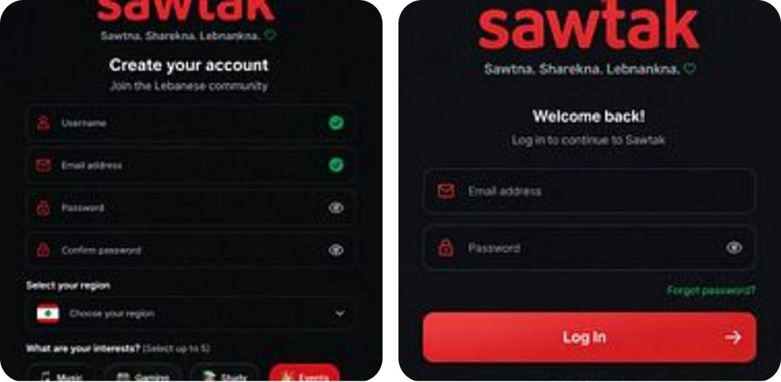
Figure 5.1 — Authentication — sign up and log in. This figure shows the authentication flow of the application. The AI will run verification before the account activates.
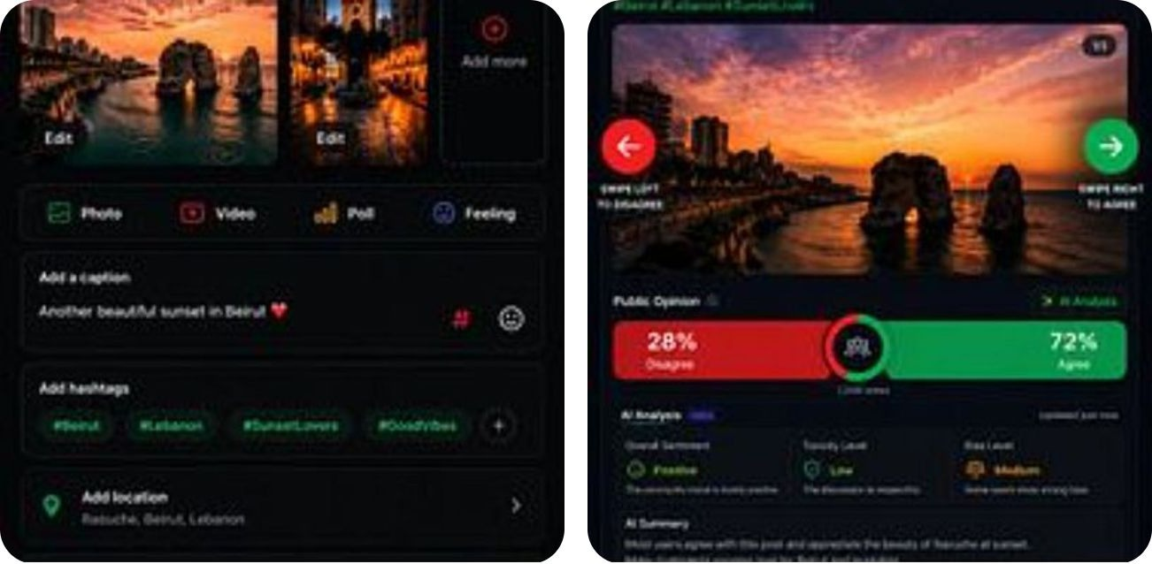
Figure 5.2 — Create Post and Home Feed. Users can create posts and use the home feed. The interface uses a swipe left to disagree and swipe right to agree system. The feed shows live percentages of the public opinion on the post along with an AI analysis panel.
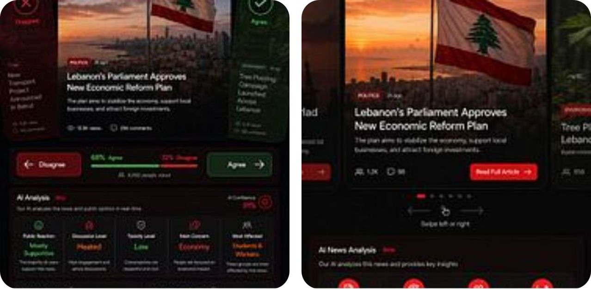
Figure 5.3 — News Feed and AI Analysis. The news feed feature will show news articles from various sources and will use the AI to check the claims made by the articles. Each claim will have a verification score of 0–5 based on the evidence found by the AI.
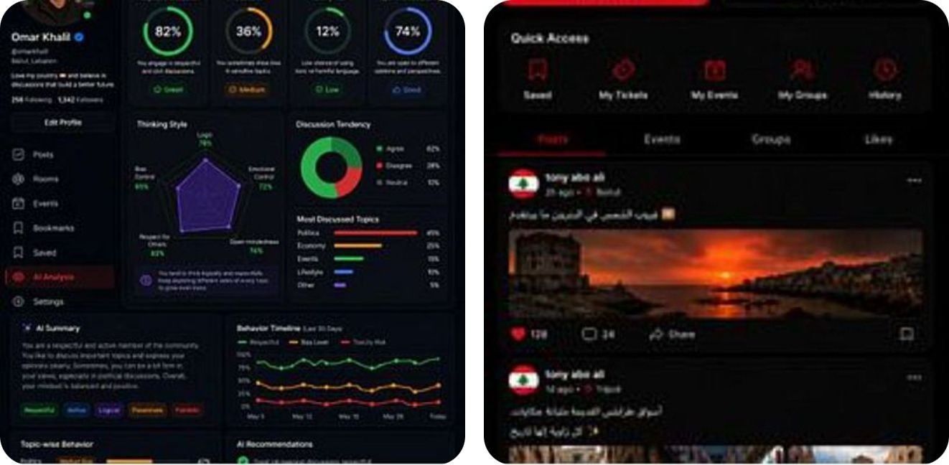
Figure 5.4 — Profile and AI Behavioural Analysis. Each user will have a profile on the application. The application will use the AI to analyse the user’s behaviour on the platform and create a private self-awareness feature that is visible only to the user.
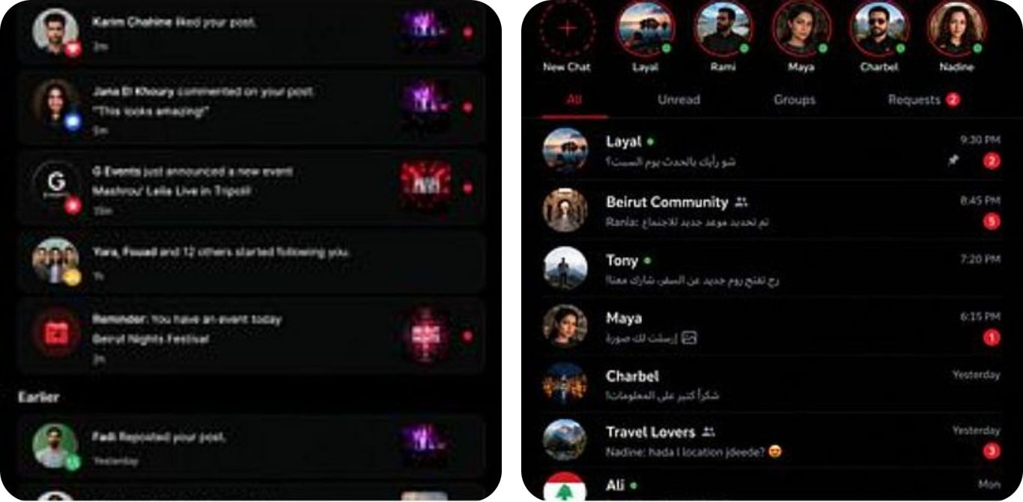
Figure 5.5 — Messages and Notifications. Users can send direct and group messages. The feature supports Arabic and English and has notifications for various events within the application.
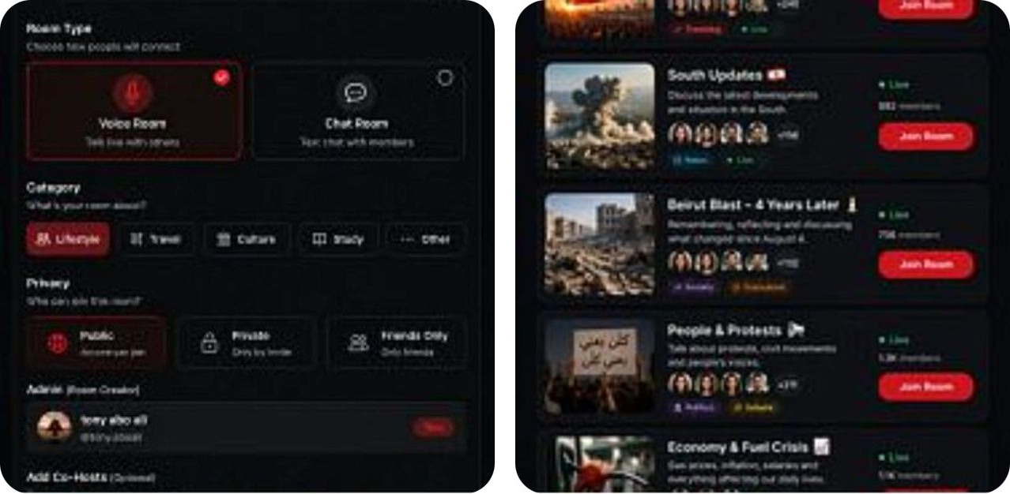
Figure 5.6 — Rooms List and Create Room. The application has chat rooms that users can join. The rooms have different topics, such as trending, political, economic, and society. Users can also create their own chat rooms.
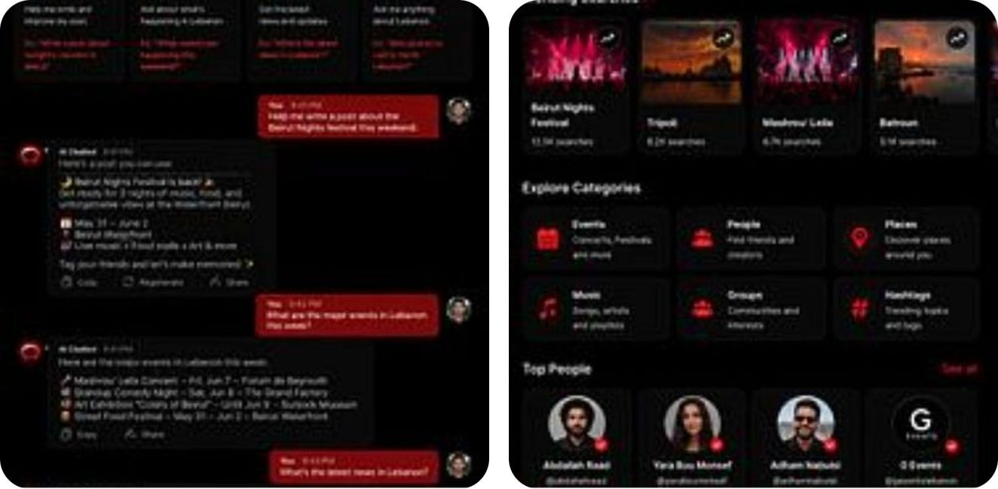
Figure 5.7 — Search and AI Chatbot. Search people, posts, events, hashtags, and trending topics, or ask the assistant .
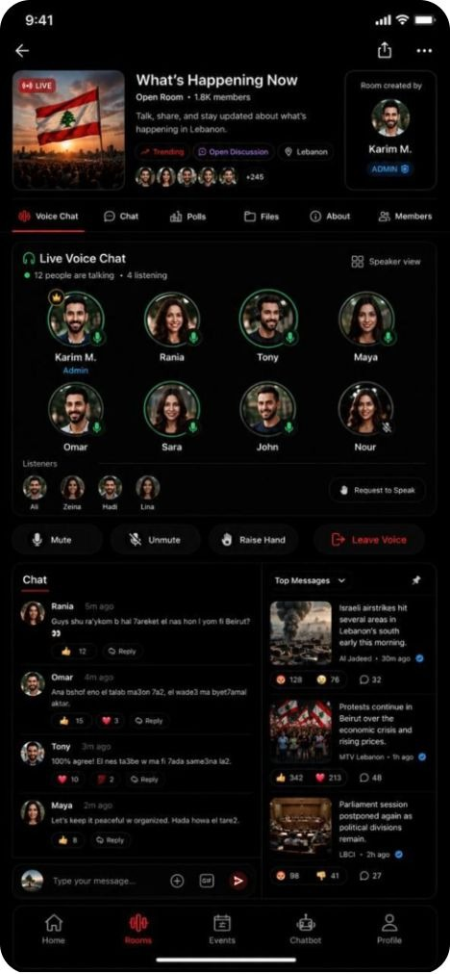
Figure 5.8 — Live Voice Room.
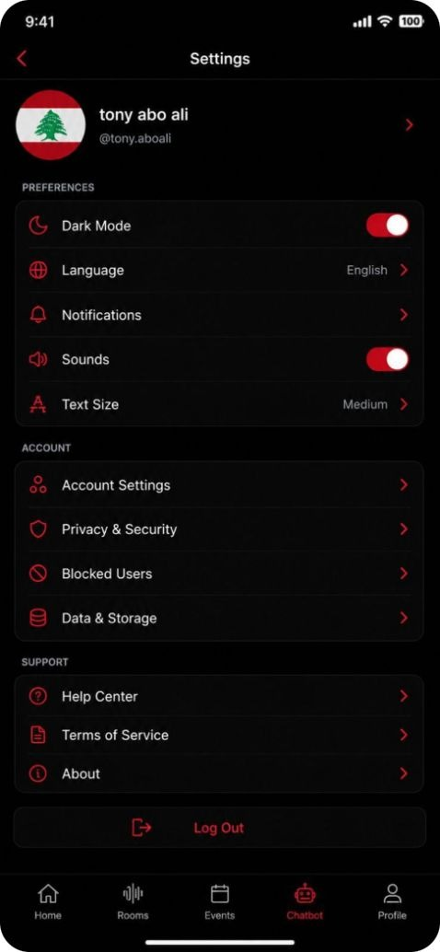
Figure 5.9 — Settings.

B. Use Case Diagram
The use case diagram shows the boundary of the Sawtak system, the three actors that interact with it, and the relationships between user-initiated use cases and the automated services they invoke.
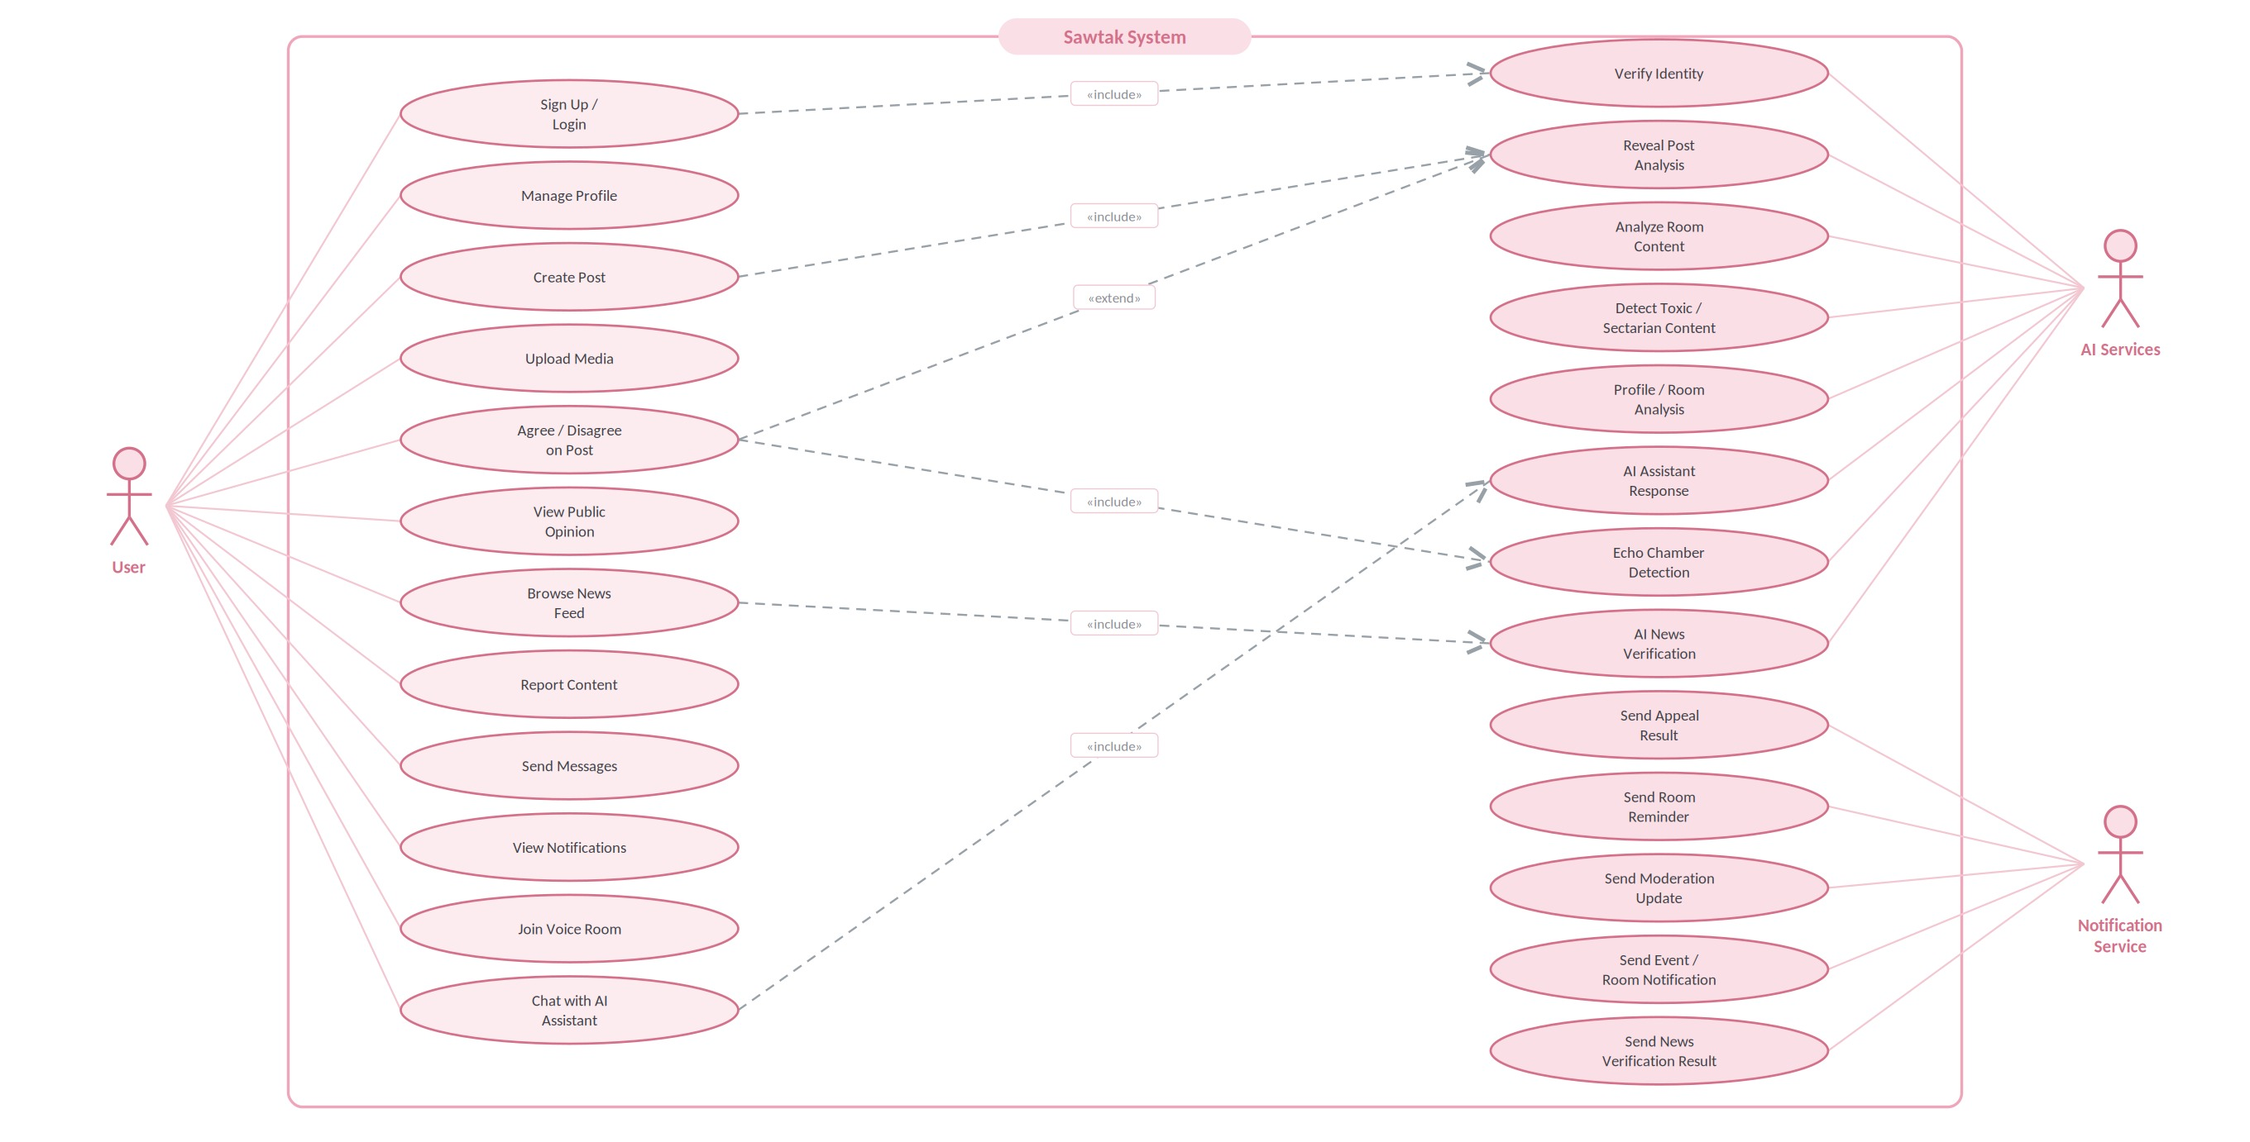
Figure 5.10 — Sawtak use case diagram

On the left side of the diagram, you can find the use cases that are initiated by the users of the platform. On the right side of the diagram, you can find the use cases that are initiated as a result of those user actions. There are two types of relationships between these use cases. Include relationships (for example, creating a post always includes performing post analysis) are mandatory. Extend relationships (for example, revealing the deeper post analysis extends the Agree / Disagree interaction, but only if the user requests it) are conditional. The AI Services actor includes post analysis, classification, detection, and verification. The Notification Service actor includes all the outbound delivery of messages to users.

C. Data Flow Diagram

Level 0 — context diagram

At Level 0 in the data flow diagram, the platform is represented as a single process with three outside entities. The users of the platform supply their login credentials, posts, and comments. They receive their feed results, post analysis, and updates from any chat rooms they belong to. The AI Classification Service receives the content that the users post, the requests from users for verification, and chatbot queries from the users. It returns the classification results for the posts, the verification results for the users who request them, and chatbot responses for any chatbot queries from the users. The Notification Service receives requests for reminders from chat rooms, updates from moderators who have made changes to content in the platform, and appeals that have been decided (results of the appeals). It returns delivery or failure status for those notifications.
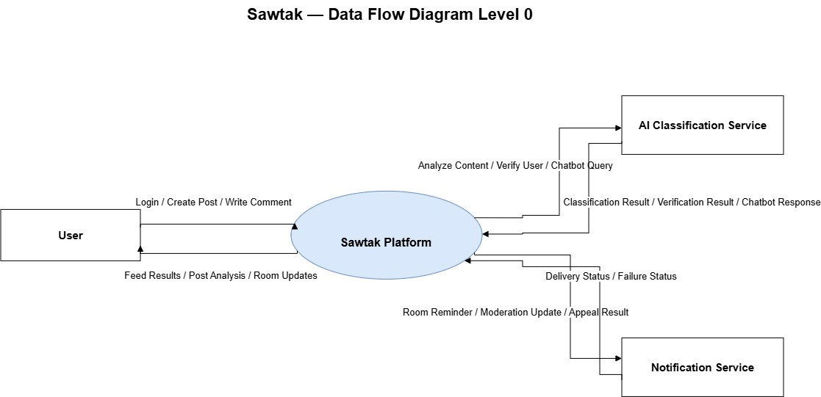
Figure 5.11 — Data flow diagram, Level 0 (context diagram)
Level 1 — decomposition

Level 1 decomposes the platform into seven processes and their data stores, as follows: 1.0 Manage User Accounts, 2.0 Manage Posts and Interactions, 3.0 AI Content Analysis, 4.0 Manage Debate Rooms, 5.0 Search and Profiles, 6.0 Moderation and Reports, and 7.0 Communication Services. The data stores consist of D1 User, D2 Posts, D3 Comments, and D4 Rooms.
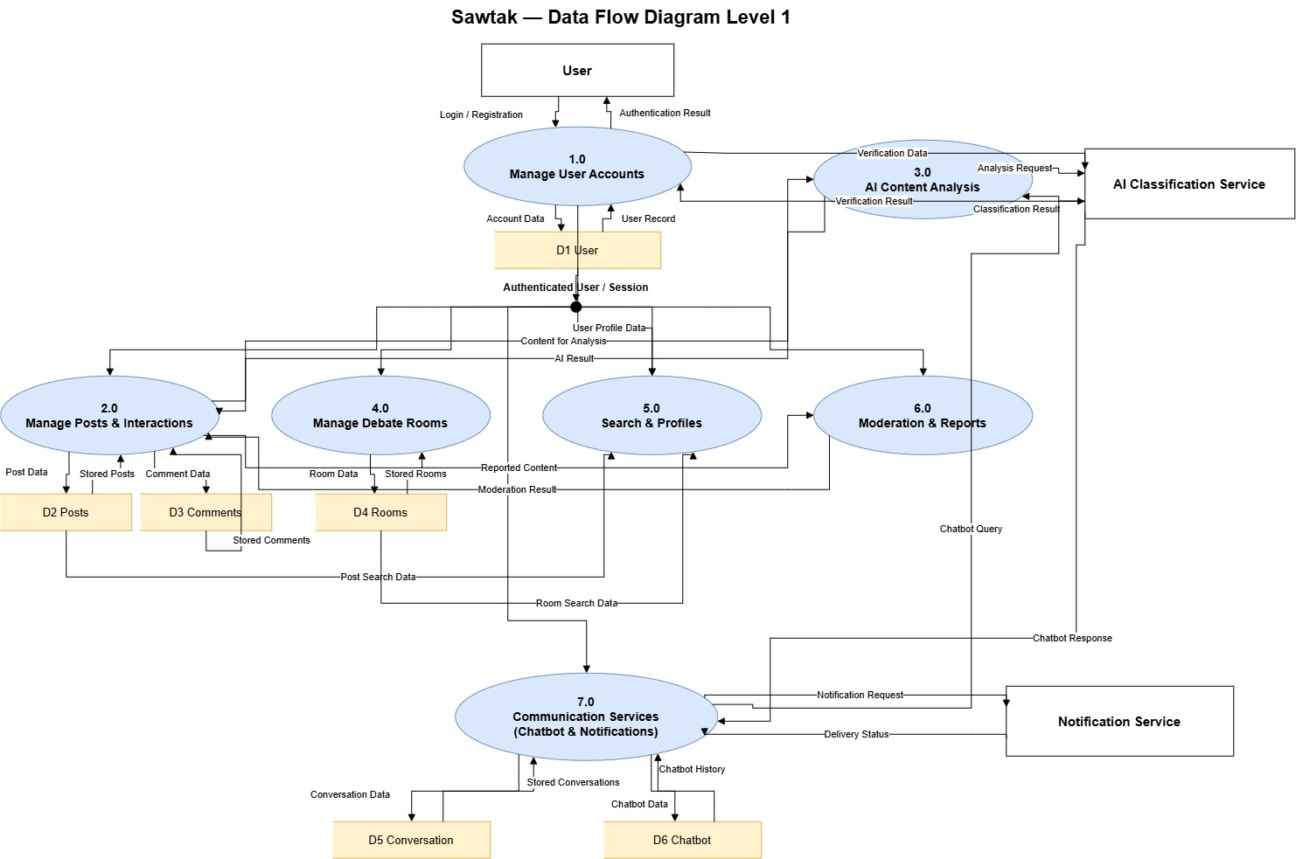
Figure 5.12 — Data flow diagram, Level 1

The interfaces between the modules follow directly from the decomposition of the system into processes and data stores. Process 1.0 is the only process that writes to data store D1 and is also the only process that calls the verification service during the authentication stage. Process 3.0 is the only process that calls the AI Classification Service, making it easy to replace this AI provider with another. Finally, process 2.0 manages the posts and interactions between users but relies on process 3.0 to provide the analysis of those interactions.

D. Database Diagram
Sawtak stores its data in a relational database (PostgreSQL, hosted on Supabase). The entity relationship diagram below shows the core entities and their relationships.
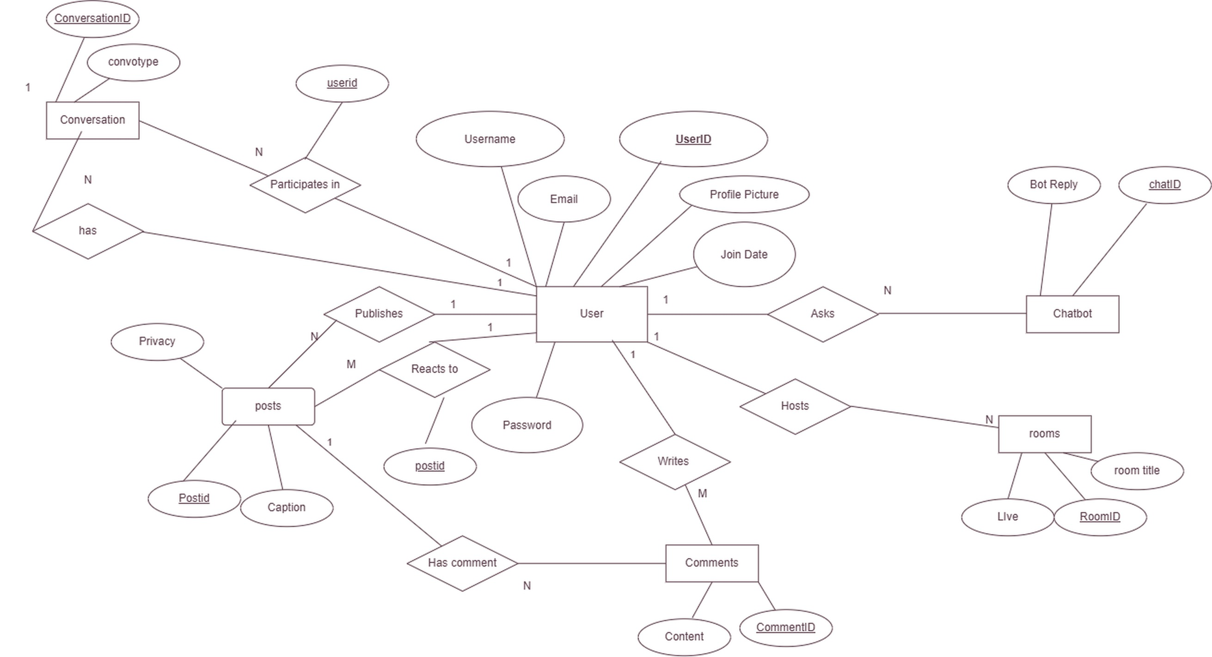
Figure 5.13 — Entity relationship diagram
The data the system stores falls into five groups. Identity and profile data is held in User: user identifier, username, email, hashed password, profile picture, and join date. Content is held in Post — identifier, caption, privacy setting, and media — and in Comment, which holds content and its identifier. Interaction data is captured by the Reacts to relationship between User and Post, which records the Agree / Disagree signal that the entire opinion measurement depends on. Discussion data is held in Room, with room identifier, title, and live status, and in Conversation, which groups participants for messaging. Assistant data is held in Chatbot, which stores the chat identifier and the bot reply.
How the relationships resolve

Within the social media model, all relationships are one-to-many except the Reacts to relationship, which is many-to-many: many users react to many posts. This relationship becomes its own table in the database, containing the identifiers for each user and post, the direction of the reaction, and the timestamp of when the reaction occurred. It is no coincidence that the only relationship requiring resolution is the one that contains the opinion data. That table is the source of the public opinion percentages, the user’s opinion profile on issues, and the measurement of the echo chamber.

In addition to the entities mentioned above, each post stores the analysis that was produced at the time the post was created (its category, topic, and position on a 0-5 scale). Each verification request also stores its score, its status, the sources that were retrieved for verification, the date of the post being verified, and the timestamp of the verification process, so that the results can be displayed without re-running the verification process.

Action required. While the presentation includes Message as one of the core entities, and slide 25 includes direct and group messaging as features on the platform, no Message entity exists in the diagram. Currently, Conversation groups participants, but there is no entity for the messages themselves. It is strongly recommended to add a Message entity (identifier, conversation, sender, content, type, timestamp) prior to submitting the project. Two smaller corrections include changing the LIve attribute found under Room to Live, and changing all entity names to their singular forms (Post, Comment, Room rather than posts, Comments, rooms).

E. Domain/Class/Object Diagrams
The class diagram below shows the major classes, their attributes and operations occured.
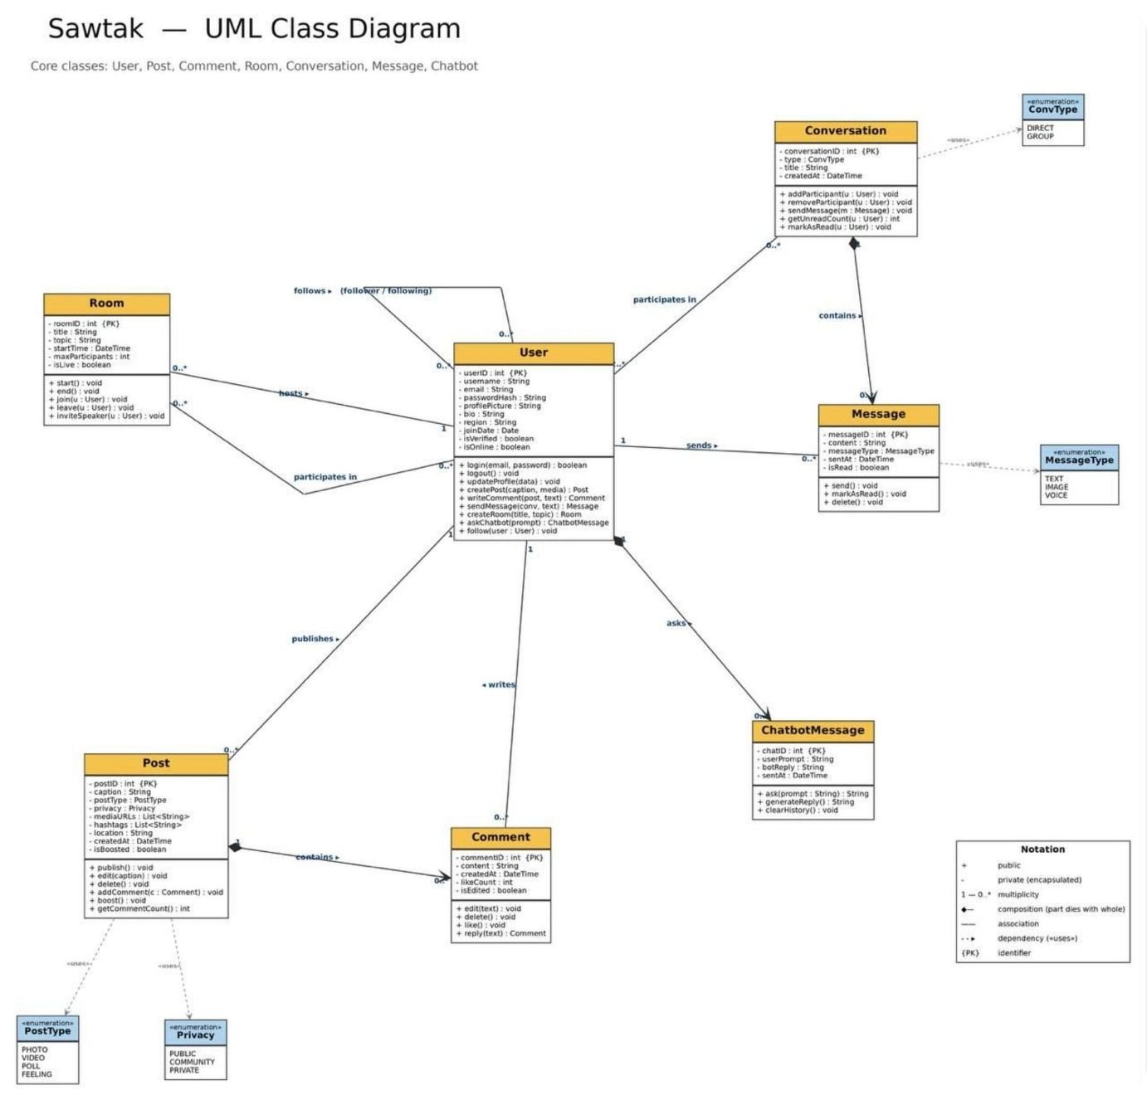
Figure 5.14 — UML class diagram

Three design decisions in the model are worth stating explicitly, as they offer answers to the questions that the design is most likely to be challenged on.

• Use of enumerations rather than strings. PostType, Privacy, ConvType, and MessageType are declared as enumerations, rather than strings. As a result, invalid values cannot be entered into the system for these data fields. The use of the type system rather than validation code at each call site ensures that these values are constrained appropriately.

• Use of composition where the child cannot exist alone. Post contains Comment, and User owns ChatbotMessage. These two relationships are defined using composition, as indicated by the filled diamond on the diagram. Therefore, the removal of User, for instance, will also remove ChatbotMessages created by that user. Similarly, deletion of a Post will also remove all Comments within that post. On the other hand, the relationships between Room and Conversation are associations, indicating that these two entities can exist independently of each other. Deletion of a Room will not remove its associated Conversations, for instance.

● A self-association on User for following. Following is a self-association on User, indicating that users can follow other users. As a result, this many-to-many relationship will be represented by a join table containing the identifiers of the follower and the followed users.

Action required. The AI classifier interface, which makes the AI provider substitutable (as discussed in NFR6 and in Section 2.C), is described in the architecture but has yet to be drawn as an interface within the class diagram. Incorporation of this interface, as well as the introduction of an abstract Content parent class for Post, Comment, and room messages, would make the moderation pipeline and the ability to substitute the AI provider visible in the model. These features are the strongest arguments for the engineering of this project, so they are worth showing in the class diagram.

F. Sequence Diagrams

Two sequence diagrams corresponding to UC-4 and UC-5 are presented below. These use cases exercise the technical contributions of this project.

Sequence 1 — Echo Chamber Breaker (UC-2 and UC-4)

This sequence diagram demonstrates how a post is created and analyzed, stored in the database, and how the user’s opinion profile is updated. It also shows how the system detects if the user is in an echo chamber, selects candidates that would potentially break the user’s echo chamber, identifies the common ground between the user and each candidate, and then returns the perspective card to the user.
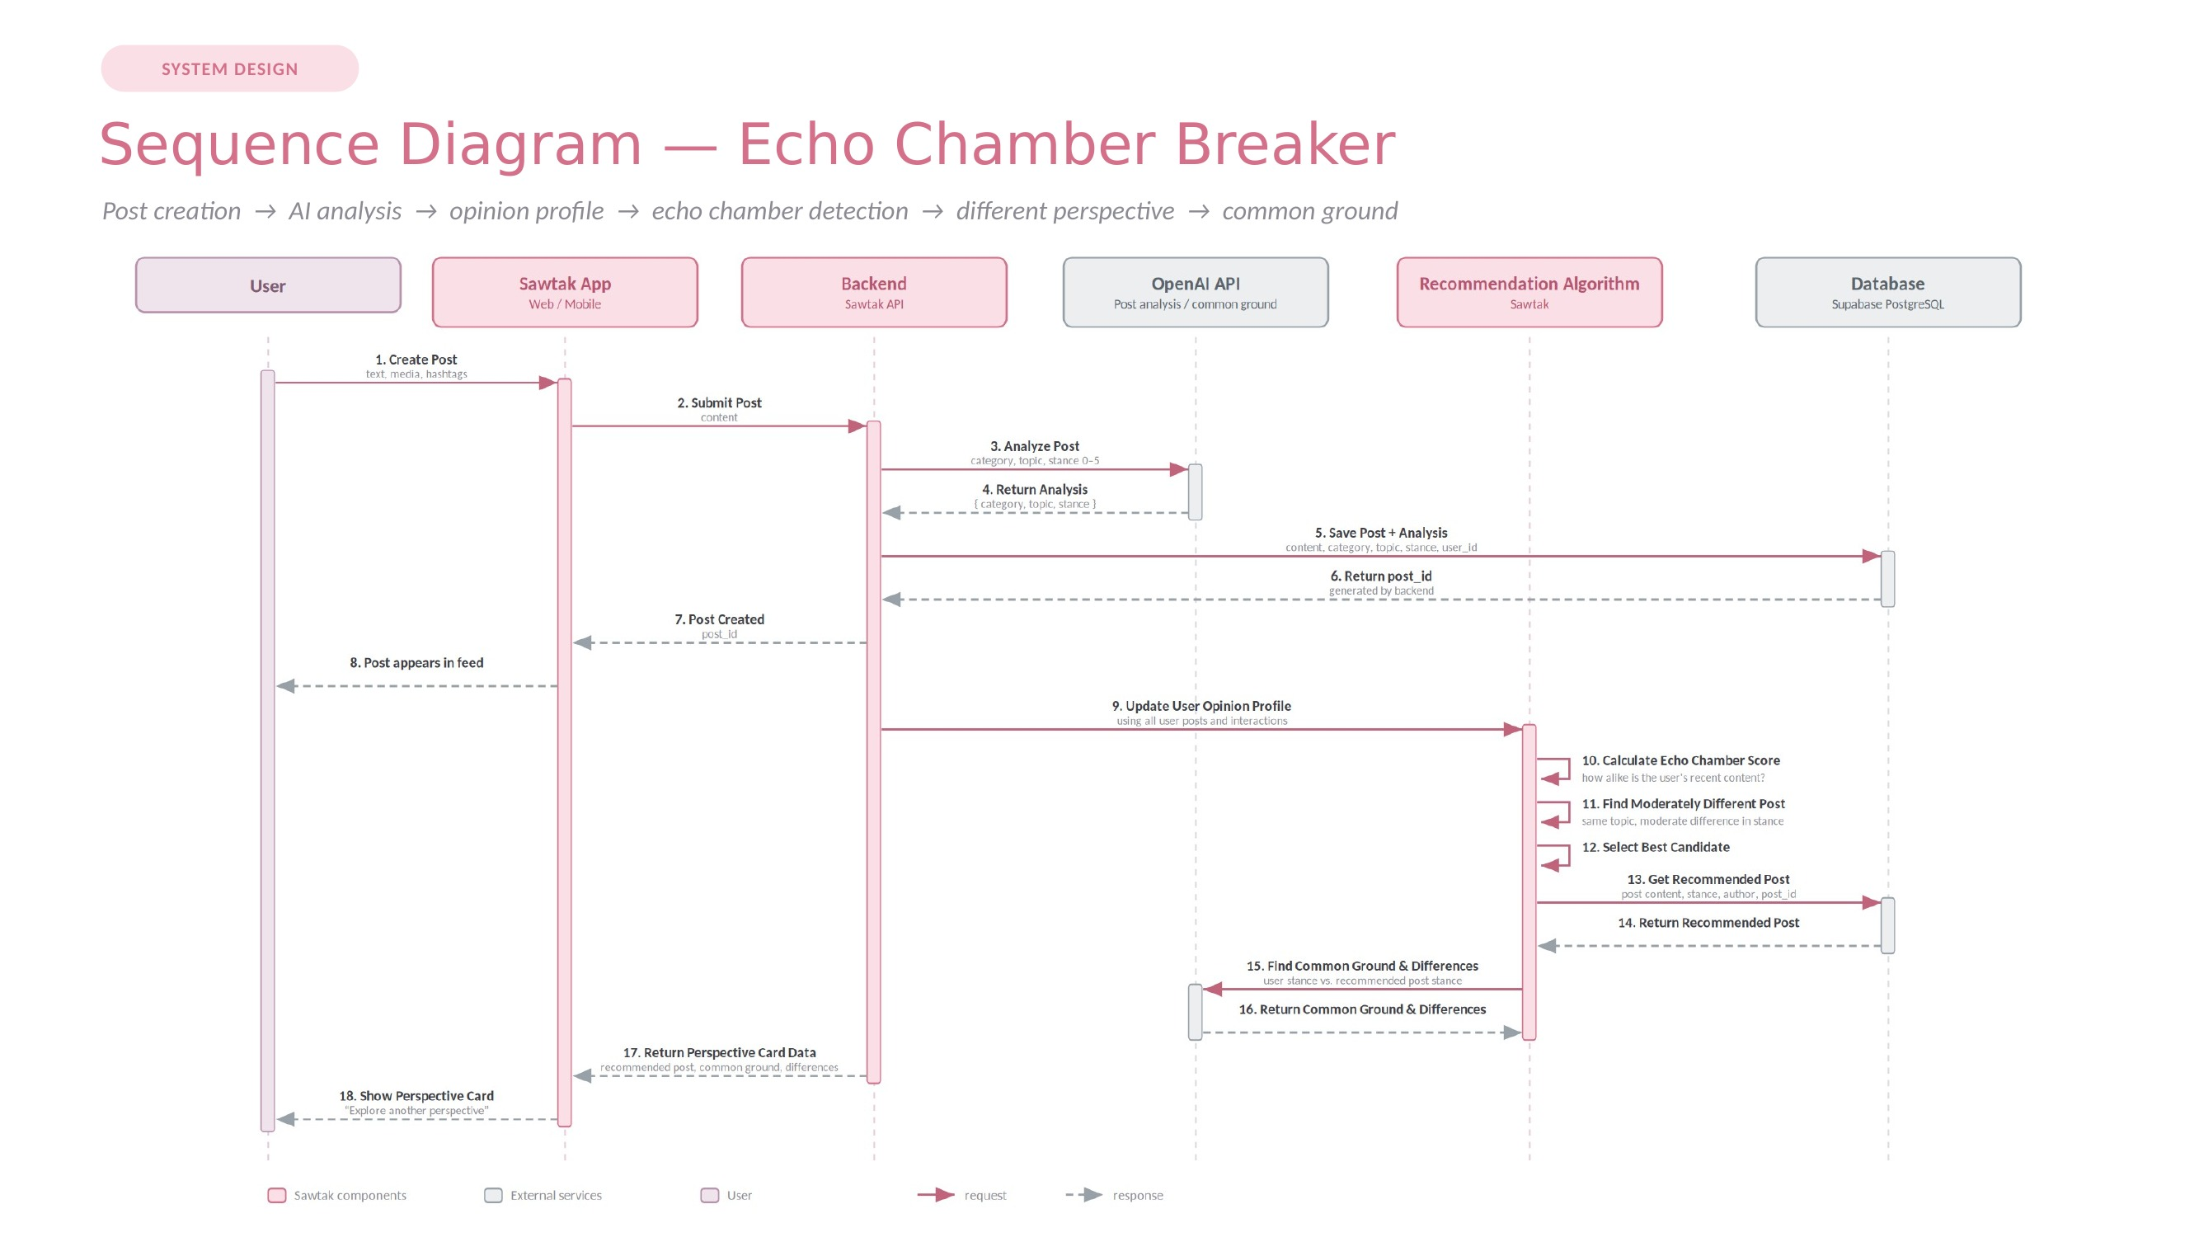
Figure 5.15 — Sequence diagram: post creation and the Echo Chamber Breaker

Three points in this sequence carry design weight. First, the analysis of the post to determine its category, topic, and stance occurs prior to storing the post in the database (steps 3 to 5). Second, the selection of the recommended post to accompany the Echo Chamber Breaker uses the Sawtak recommendation algorithm (steps 10 to 12), rather than the AI service. Finally, the common ground between the original post and the recommended post is determined before displaying the card (step 15).

Sequence 2 — News verification (UC-5)

This diagram traces a verification request from the user through claim extraction, evidence retrieval, matching, classification, scoring, and explanation, to the evidence panel.
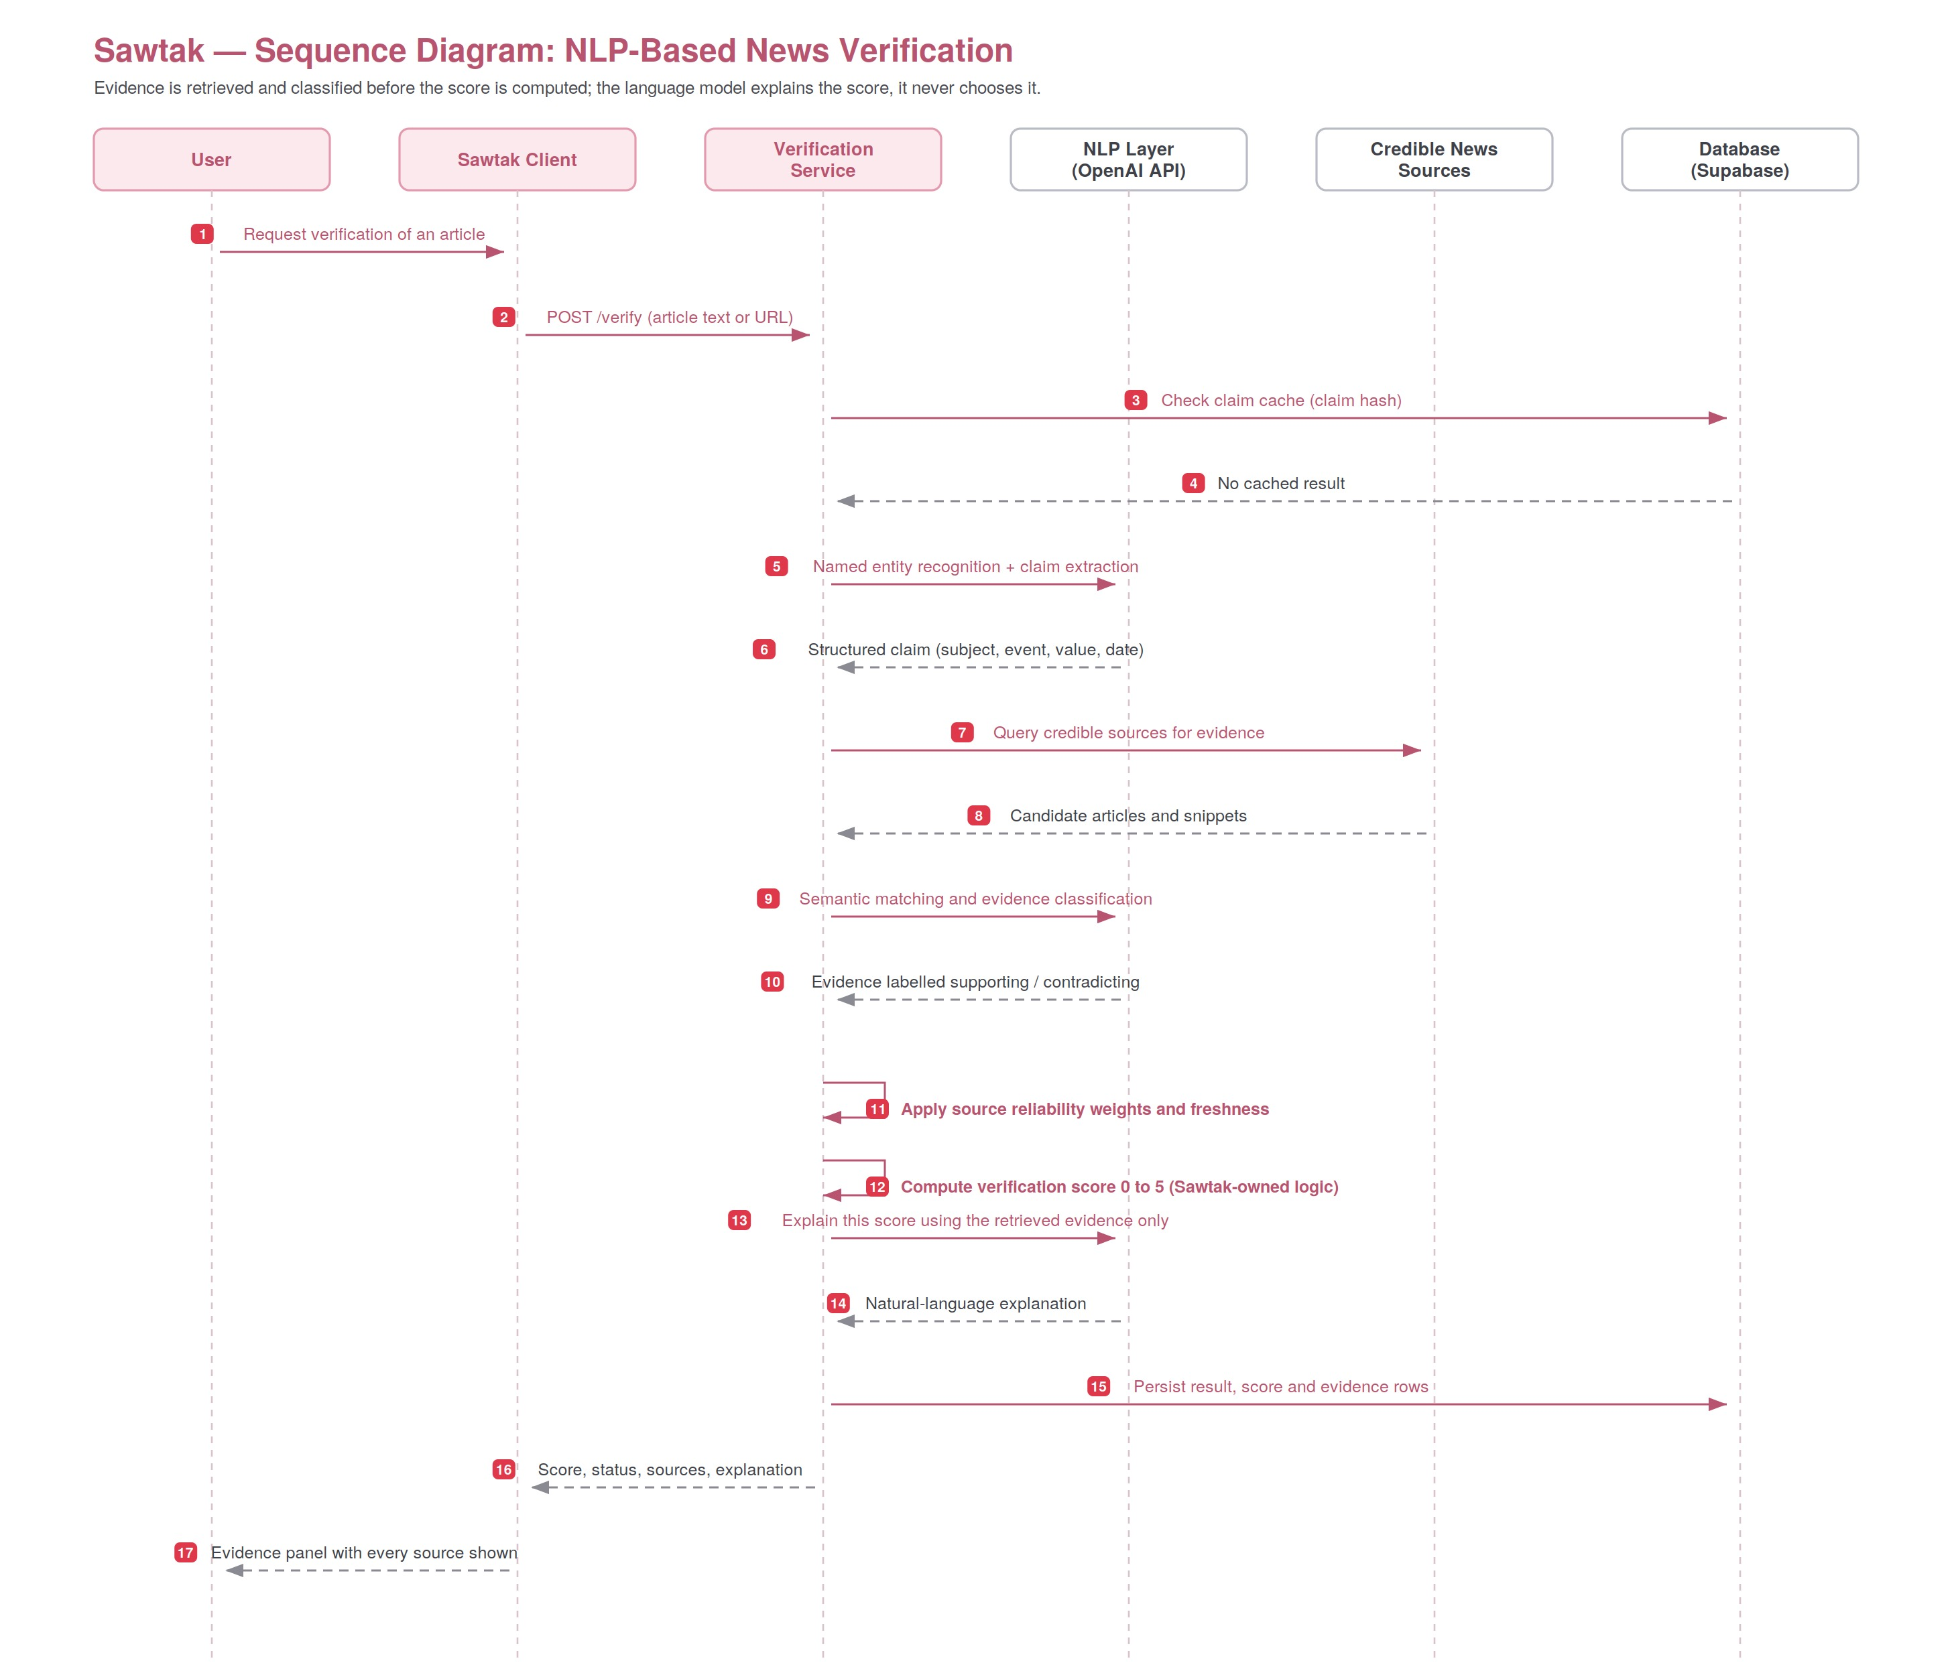
Figure 5.16 — Sequence diagram: NLP-based news verification

A critical aspect of this pipeline is the ordering of steps 12 and 14. The news verification score is calculated by Sawtak-owned logic from the classified evidence. Then, a language model is asked to generate an explanation of the score from the evidence alone. The model itself does not generate the score. This fact alone ensures that the pipeline is evidence-first rather than model-first. This architectural decision addresses the risk of hallucination by the AI language models as discussed in Section 3.F.

G. Architectural Diagram

Sawtak employs a layered architecture for its components. Each layer depends only on the layer directly beneath it, and all communications with the external world occur through the combining layer.
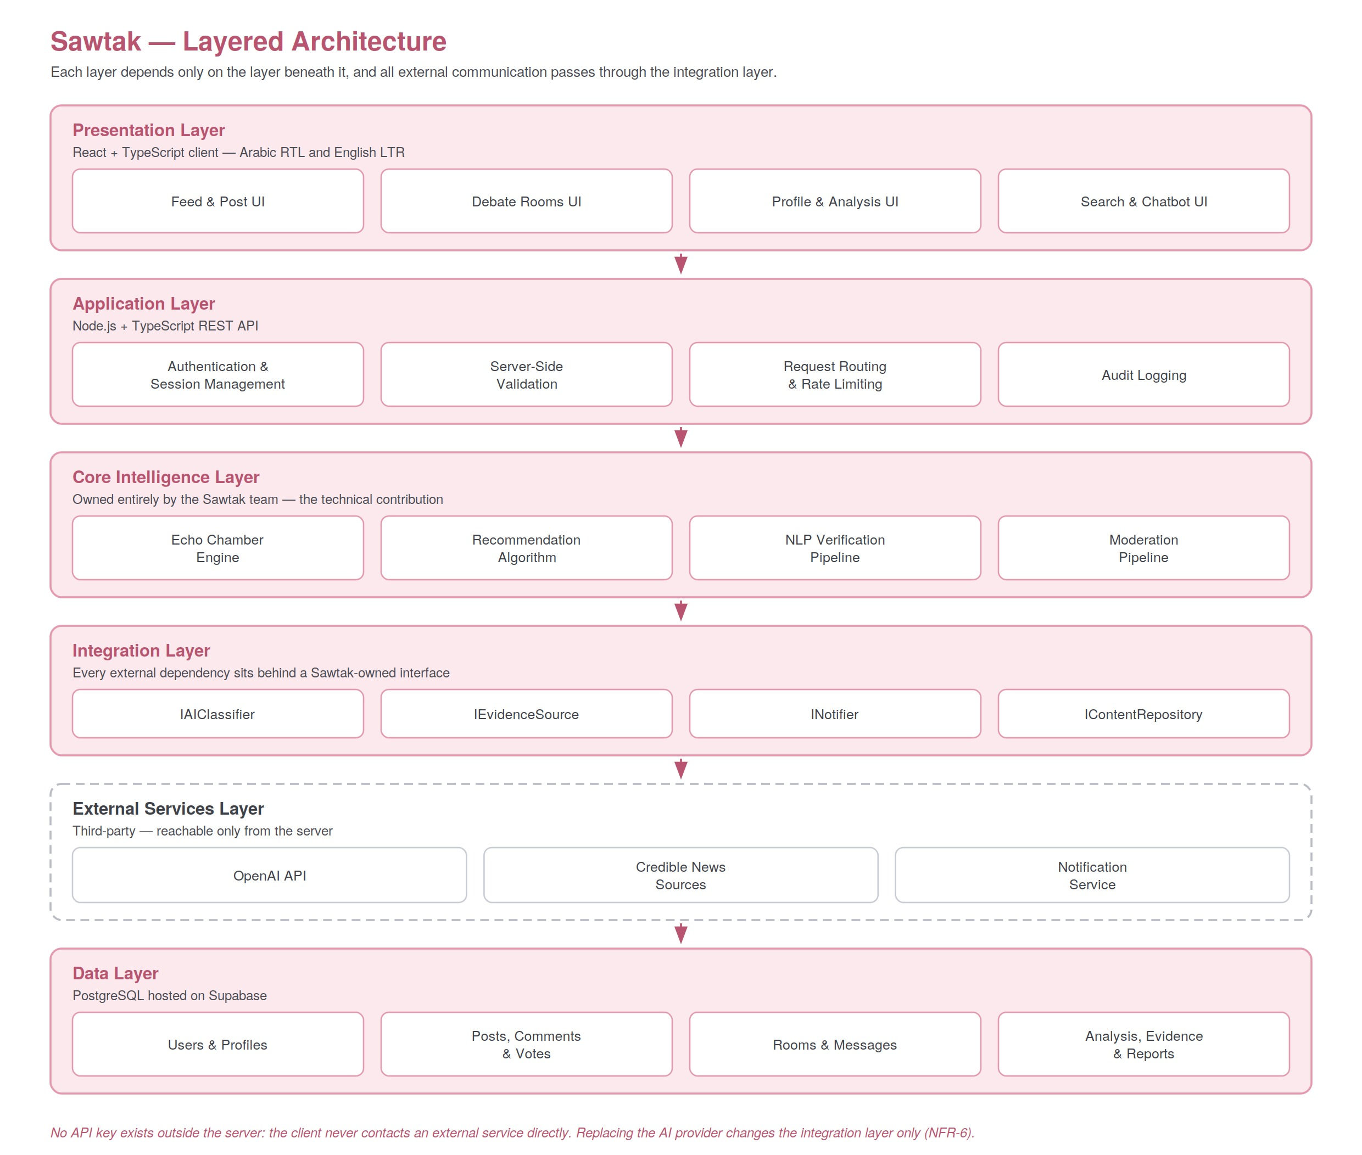
Figure 5.17 — Sawtak layered architecture

The presentation layer uses React and TypeScript. It supports Arabic (right-to-left) and English (left-to-right) layouts. The application layer uses Node.js and TypeScript in a REST API. It manages authentication, sessions, validation, and audit logging. The core intelligence layer contains the technical contributions of the project: the echo chamber engine, recommendation engine, and NLP verification pipeline. The combining layer isolates all external dependencies behind a Sawtak-owned interface. The external services layer includes the OpenAI API, news sources, and notification service. Finally, the data layer uses PostgreSQL with Supabase hosting.

From this arrangement, two properties are evident. First, the client does not contact external AI services directly. The API key is stored on the server, and calls to the AI service are proxied through the backend. Second, if the AI provider were to be replaced, the only change would be in the integration layer. None of the other layers contain a reference to an AI provider. Thus, this property expresses the requirement NFR-6.

Chapter 6. Implementation Plan
A. Technical Resources

The technology stack below lists only the confirmed technologies that will be used for this project. The stack excludes those platforms that have not yet been confirmed for use in this project.

Layer Technology / platform Language(s) Frontend React TypeScript, HTML, CSS Backend Node.js TypeScript Database PostgreSQL / Supabase SQL AI services OpenAI API — Core intelligence Custom Echo Chamber algorithm (Sawtak-owned) TypeScript Core intelligence NLP News Verification pipeline (Sawtak-designed) TypeScript Embeddings (optional) OpenAI Embeddings Under evaluation Table 6.1 — Technology stack

Why these tools

• React and TypeScript are used for the frontend of this project because the component model of React is perfect for an interface that will display many of the same types of content repeatedly. Also, React’s support for internationalisation can support the requirement for displaying content in both the right-to-left and left-to-right directions. The use of TypeScript also ensures fewer integration errors between the modules of the application, especially as a five-person team develops it.

• Node.js with TypeScript is used for the backend because the use of the same language for the frontend and backend can reduce the cost of context switching for the student team. Also, defining the requests and responses in one place allows these types to be reused on both the frontend and backend.

• PostgreSQL and Supabase were selected because the data that is being managed by this project is inherently relational, as outlined in Section 5.D of the project plan. Supabase’s managed PostgreSQL database with authentication and storage is suitable for the scale of the project as it is still in the prototype phase.

• OpenAI API will be used as an external service for the classification and explanation of content. The API removes the need for training models, which allows the project to remain within the state of practice as defined in Section 2.C of the project plan.
Off the shelf versus built from scratch

One of the most important distinctions to make about this project is what parts of the application are built off the shelf versus from scratch. Off the shelf parts of the project include the language model, the database engine, authentication primitives, hosting platform, and frontend framework. Parts built from scratch include the echo chamber scoring system, the opinion profile creation system, the recommendation algorithm, the evidence matching logic, and the verification scoring system. Using the OpenAI API as a service but creating the core intelligence for the application from scratch gives the project its technical innovation and contribution to the field.

Proposed API endpoints

Endpoint Function POST /api/auth Use this endpoint for account authentication, including AI Verification. POST /api/posts Use this endpoint to create posts that will trigger AI analysis of the content to determine category, topic, and stance. GET /api/feed Use this endpoint to retrieve the personalised feed. GET /api/recommendations Use this endpoint to retrieve perspective recommendations with common ground between the user and friends. GET /api/opinions Use this endpoint to retrieve the user’s opinion profile. POST /api/interactions Use this endpoint to record the user’s Agree / Disagree interactions. POST /api/verify Use this endpoint to verify news claims to return a score and evidence of the verification. Table 6.2 — Proposed API endpoints (subject to refinement during implementation)

Key management and security

• The OpenAI API key will exist only on the backend server and be loaded from environment variables.

• API keys will never appear anywhere in the React frontend, in the browser, in the page source, or in a public repository.

• All calls to OpenAI and other external services will be routed through the Sawtak backend server. The client will never call an AI API directly.

• Every request will be validated on the server. AI and authentication API endpoints will also be rate-limited.

B. Testing Plan
No testing results are presented in this report; the testing will be conducted in the Senior Project II course. The testing strategy is defined here so that each requirement has means of verification prior to implementation. There are six categories of requirements that will be tested. These six categories cover the functional requirements of the project, the integration requirements, the requirements for the two technical innovations, the requirements for security, and the requirements for usability.
Test category What is tested and how
- Functional testing Authentication including AI Verification, posts, Agree / Disagree, comments, rooms, messaging, and reports — verifying FR-1 through FR-13. Each functional requirement is exercised by at least one test case derived from the use case descriptions in Section 4.C.
Test category What is tested and how
- Integration testing Frontend to backend to database to OpenAI and external services, verifying end- to-end data flows across every layer of the architecture in Section 5.G. Particular attention to the asynchronous analysis path, since the feed must never block on a model call.
- Echo Chamber testing Stance classification consistency, opinion profile updates, echo chamber score behaviour, whether recommendations are genuinely moderately different rather than identical or opposite, and common-ground relevance. Weight tuning is evaluated here.
- NLP verification testing A set of labelled news claims evaluating named entity recognition, claim extraction, evidence retrieval, supporting and contradicting classification, temporal handling, and the accuracy of the 0–5 score. Temporal handling is tested specifically with same-wording, different-year pairs.
- Security testing Authentication, authorisation, input validation, rate limiting, and API key protection — confirming that no credentials are exposed in the frontend or in public code.
- Usability testing Whether users understand the Agree / Disagree mechanic, the AI analysis, the perspective recommendations, and the 0–5 verification score. Tested with both Arabic and English speakers, since the interaction model must work in both. Table 6.3 — Testing plan
Unit tests cover the Sawtak-owned logic of scoring, matching, and profile construction, because that logic is deterministic and is where the project’s own defects will occur. System and integration tests cover the paths that cross a boundary into an external service. Usability testing is a first-class category, not an afterthought, because the central premise of the platform is that a change in interaction mechanics changes behaviour; if users do not understand the mechanic, the premise fails regardless of implementation quality.

C. Deployment Plan
All of the platform’s components are built exclusively using managed cloud services without any use of self-hosted servers. Supabase provides managed PostgreSQL for the database and authentication services. The Node.js backend and React frontend will be hosted by a managed hosting provider at free or student tier level at the stage of prototyping.

• Environments — one development environment on each member’s computer, and a single staging and demo environment for Senior Project II. A production environment will be introduced only if the platform will become publicly available outside the university.

• Configuration — all secrets, including the OpenAI API key, are provided using environment variables on the server side. There is no secret committed into the repository at any point of time.

• Database migrations — any modifications of the schema are done through versioned migration scripts so that the state of the schema is reproducible, rather than being managed manually.

● Release strategy — incremental. Every release increment introduced in Section 3.B will be delivered to staging and demo’d before moving onto the next one so that partial release will result in a fully functional system.

To be confirmed. Provide the name of the chosen hosting provider for the frontend and backend and the location of the data storage area (required for the data protection position in Section 2.A).

D. Maintenance Plan
• Version control — Git, using a centralized repository. Development is done on feature branches, and updates to the main branch happen only by way of a reviewed merge, ensuring that no single team member has exclusive access to any part of the source code.

• Bug tracking — Issues are logged based on the increment they affect, complete with a severity rating and ownership, and are closed only upon successful testing.

• Dependency management — The dependency most likely to change is the AI provider and the various model versions. Since all of these rest behind the interface outlined in Section 5.G, updating them is a matter of changing one layer of functionality and not the entire platform.

• Monitoring — The monitoring involves API usage and costs because they represent the greatest operating expenses as well as environmental expenses. The rate limiting and caching are validated in the production environment and not assumed.

• Data management — The stored analysis and verification results are kept in order to avoid the need for recalculation, but they are recalculated whenever there is a change to a model version.
To be confirmed.

Chapter 7. Summary and Future Work
This tool does not aim to get rid of debate. It aims to make online debate healthier.

Senior Project I has shown that this goal is within reach. The problem was observed and confirmed with the help of primary evidence from 88 Lebanese participants, 93% of whom use social media several times a day, 75% of whom come across harmful or offensive content at least sometimes, and 36 of whom consider toxic comments and hate speech among their worst problems. A literature review failed to find any existing platform that offered the combination of news verification, structured opinion debate, echo-chamber correction and Lebanese focus. A feasibility study came out positive for all six criteria and stated the residual risks associated with each of them.

This phase has produced a full set of deliverables including a detailed requirements specification with thirteen functional requirement groups, six non-functional requirement groups, eight domain requirements for the Lebanese situation, prototypes for each of the features and seven design models (use case, two levels of data flow, entity relationship, class, two sequence diagrams and layered architecture).

A technological contribution of this project is based on a simple yet consistent rule. The language model classifies and explains, but Sawtak decides which perspective is chosen for a recommendation. The algorithm calculates the score from the classified content and only after that asks the model to provide explanation for it. The AI vendor stays hidden behind an interface, so that replacing the vendor would require no changes to the other layers. This gives the project the ownership of the decision-making process and makes it certain that there will be no profiling of users according to religious, sectarian, political and ethnic criteria.

Future work
The implementation discussed in Section 3.B will be implemented in Senior Project II with all the elements including the platform, AI service layer, innovations, moderation, testing and accuracy assessment, and deployment. There are three implementation aspects discussed above which bring a high risk to the project and require special attention in the implementation phase. First, Lebanese Arabic and code-switching are the most difficult technical problem of the current project and its solution will be evaluated against the mixed-language sample. Second, the recommendation weights, set to 40%, 40% and 20% for topic match, opinion difference, and user interest respectively, are configurable and should be optimized against user behavior rather than being fixed. Finally, the requirements from NFR-4 have yet to be quantified and measured.

There are six additional steps for improving the verification pipeline which were envisioned but are outside the scope of the current project and represent the natural future step in development. These include duplicate detection, event clustering, news timeline generation, entity linking, claim decomposition and temporal reasoning with fact provenance. In the long term, the platform generates valuable data about opinions expressed by the public and dynamics of opinions and discourses.

We do not strive to make everyone agree with each other. We strive to make the disagreement healthy.

Chapter 8. References
References conform to IEEE format. Asterisk marks primary data collected by the research team.

[1] *Sawtak project team, “Sawtak user survey: Lebanese social media use, exposure to damaging content, and platform expectations,” unpublished primary data, 88 respondents, Beirut Arab University, 2026.

[2] Republic of Lebanon, Law No. 81 of 2018 on Electronic Transactions and Personal Data, Official Gazette, Beirut, 2018.

[3] I. Sommerville, Software Engineering, 10th ed. Harlow, U.K.: Pearson Education, 2015.

[4] R. S. Pressman and B. R. Maxim, Software Engineering: A Practitioner’s Approach, 8th ed. New York, NY, USA: McGraw-Hill Education, 2014.

[5] IEEE, IEEE Recommended Practice for Software Requirements Specifications, IEEE Std 830-1998, Institute of Electrical and Electronics Engineers, 1998.

[6] Object Management Group, OMG Unified Modeling Language (OMG UML), Version 2.5.1, Object Management Group, 2017. [Online]. Available: https://www.omg.org/spec/UML

[7] OpenAI, “OpenAI API documentation.” [Online]. Available: https://platform.openai.com/docs

[8] Meta Open Source, “React documentation.” [Online]. Available: https://react.dev

[9] OpenJS Foundation, “Node.js documentation.” [Online]. Available: https://nodejs.org/en/docs

[10] Microsoft, “TypeScript documentation.” [Online]. Available: https://www.typescriptlang.org/docs

[11] The PostgreSQL Global Development Group, “PostgreSQL documentation.” [Online]. Available: https://www.postgresql.org/docs

[12] Supabase, “Supabase documentation.” [Online]. Available: https://supabase.com/docs

Action required. This is the list of actual standards, legislation and technical documents that were used. Prior to the submission, include the academic literature that justifies the problem statement – published literature on filter bubbles and selective exposure, online incivility and effects of anonymity, and automated fact-checking and claims verification. All sources have to be read by the team, and each one has to be cited in Chapter 1 or Chapter 2 at the place where its finding is used.

Appendices

A. Position and Verification Scales
Two different 0–5 scales are used on the platform. These are included here jointly since the similarity between them might lead to misunderstanding: one describes a stance, and another describes evidence.

Appendix A.1 — Post stance scale (automatically calculated while creating a post)

Score Stance 0 Strongly against 1 Against 2 Somewhat against 3 Neutral / moderate – the default for an undefined stance 4 Supportive 5 Strongly supportive Table A.1 — Post stance scale

Appendix A.2 — News verification score bands (displayed to the user)

Score Status Description 0 Unsupported Credible evidence contradicts the claim. 1 Largely contradicted Main credible evidence contradicts the claim; any evidence in favor of it is questionable. 2 Conflicting reports Different credible sources give conflicting information on the same issue. 3 Partially supported The core of the claim is true, but some details (dates, numbers, etc.) are not confirmed. 4 Supported There is at least one credible independent source that confirms the claim. 5 Strongly supported There are several independent credible sources confirming the claim. — Unable to verify No enough relevant evidence was found; no score is assigned. Table A.2 — News verification score bands

B. Recommendation Algorithm Weighting
Sawtak’s recommendation algorithm selects a candidate post according to the following weighted criteria. The algorithm is suggested and is configurable; weightings will be fine-tuned in Senior Project II.

Scoring factor Weight Topic match 40%

Scoring factor Weight Opinion difference – moderate difference favored 40% User interest 20% Table A.3 – Scoring factors used in recommendations

Example calculation: for a user who has a position of 5 on a topic, the algorithm would prefer the post having position 3 – a moderate difference, over the post with position 5 – an identical position and therefore no diversity, and over position 0 – a complete opposition.

C. Worked Example — Claim Extraction and Evidence
Below is an example of how NLP layer makes this transformation and what evidence panel the user receives. The numbers presented here are only illustrative.

Stage Content Raw article text “Lebanon increased fuel prices by 15% on August 27.” Extracted entities People, places, organizations, dates, events, and numbers – in this case: Lebanon (place), fuel price increase (event), 15% (number), 27 August (date). Structured claim Subject: Lebanon · Event: fuel price increase · Value: 15% · Date: 2026-08-27 Semantic matching Three news articles formulated in different way are matched as one story about the same event: “Lebanon increases fuel prices under the economic pressure”, “Fuel prices were increased in Lebanon yesterday”, “Petrol prices increase in Lebanon announced by the Lebanese officials”. Result Score 5 / 5 · Highly confirmed · 3 independent credible sources confirm, 0 contradict · event date 2026-08-27. Table A.4 - Worked verification example (illustrative values)

Semantic similarity alone does not make this match possible. The events of 2025 and event of 2026 may be identical in wording; therefore, entity and temporal matching have to be performed in conjunction with semantic matching.

D. Echo Chamber Score — Worked Example
Echo chamber score represents the percentage of a user’s recent exposure to content that has the same point of view. Below is an example of how a distribution can be used to generate an echo chamber score of 0.80.
Exposure in the last 100 interactions Percentage with same viewpoint as the user 80% Neutral 15% With different viewpoint 5% Table A.5 – Example of Echo Chamber Score
The way in which this outcome is communicated to the user is as follows: "Content exposure has low viewpoint diversity." This is never framed in any way as "You are biased" or "You are extremist," and the recommendation that comes from this is "Explore another perspective," not a "diagnosis." The opinion profile on which this measurement is based contains only the opinions of a user on issues that they have been exposed to.

E. Remaining Items Prior to Submission
These are the issues noted in the body of the report and need attention from the team.
Section Outstanding Item Title page ID numbers of all five team members. Title page Check that the month and year of submission are correct. 3.C Project Schedule Provide the Gantt chart or the PERT diagram along with the name of the scheduling tool used. 3.D Team Roles Define the technical roles and responsibilities for each of the team members as Senior II. 3.F People and Time Identify the tools for communication, version control, and task tracking. 4.B User Permissions Include the moderator actor in the use case diagram. 4.D NFR4 Quantify the response time and uptime requirements. 5.D Database Diagram Provide the Message entity; correct “LIve” to “Live”; ensure the singular form of entity names. 5.E Class Diagram Include the interface of the AI classifier and the abstract Content class. 6.C Deployment Plan Provide the hosting provider name and the location of data storage. 8 References Include the academic references for Chapters 1 and 2. Table A.6

